1. **Memorize the concentrations of the principal ions in the extracellular and intracellular fluid.** 
   * **Na+** ECF: 140 mEq/L, ICF: <15 mEq/L
   * **K+** ECF: 4.5 mEq/L, ICF: 140 mEq/L
   * **HCO3-** ECF: 24 mEq/L, ICF: 12 mEq/L
   * **H+** ECF: 40 nEq/L (pH 7.40), ICF: 80 nEq/L (pH 7.10)
   * **total solutes** ECF: 290 mosmoles/L, ICF: 290 mosmoles/L
     + Same osmolality inside and outside for humans! unlike bacteria
   * Reminder mEq is relative to charge (mEq = charge of a mMole of ion)
   * Osmoles are relative to number of particles in solution (mosmole = mmole particles in solution)
     + Examples:
       - 1 mmol of glucose = 0 mEq and 1 mOsm
       - 1 mmol of Mg2+ = 2 mEq and 1 mOsm
       - 1 mmol of NaCl = 0 mEq and 2 mOsm
2. **Know the difference between: intracellular fluid, extracellular fluid, interstitial fluid, and plasma, and how to estimate the volume of each of these compartments in a patient.** 
   * 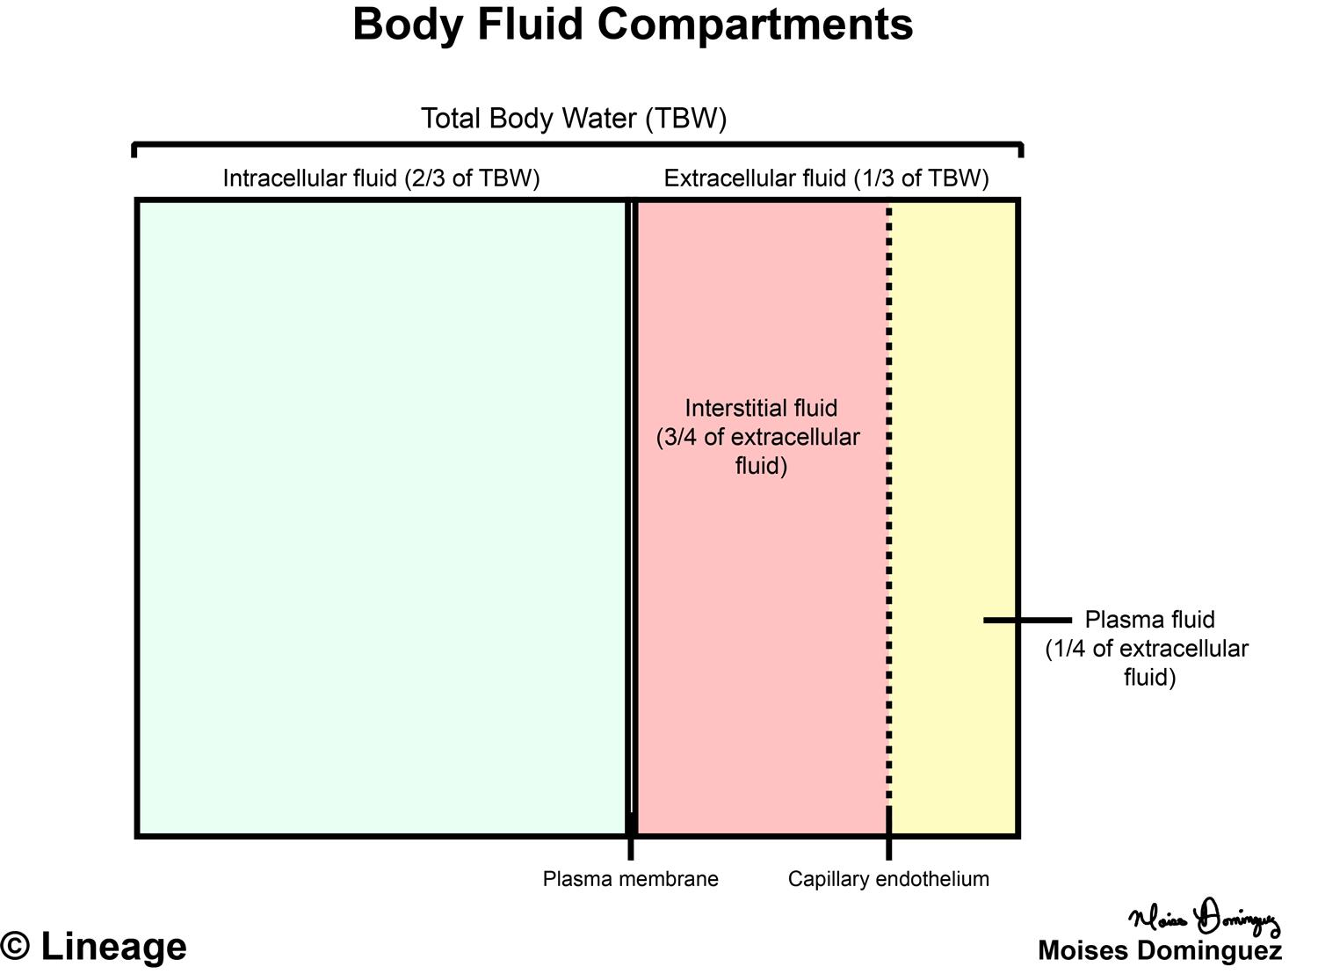
   * Intracellular fluid: ⅔ of TBW, ~28L
   * Extracellular fluid: the fluid surrounding our cells, the water in the tank, ⅓ TBW, ~14L
   * Interstitial fluid: ¾ of ECF, ~ 11L
   * Plasma: ¼ of ECF, ~3L
   * Today body water (TBW) 60% of weight 70 kg * 60% → 42L
3. **Understand the composition of two common intravenous fluids used in medicine - 5% Dextrose ("D5W") and 0.9% Sodium Chloride ("normal saline").** 
   * 5% dextrose & 0.9% saline are both 290 mosmoles/L
     + *If you give 1L saline to someone = ECF increases by 1L (*the Na+ would only go into the vascular and interstitial space, not the intracellular space because you have working Na+ pumps on the cells and they already have the amount they need, so an isotonic solution will not add Na+ to cells)
       - adds to ECF only
     + *If you give 1L dextrose to someone = ECF will increase by 1/3L*
       - adds to TBW
   * You can't give pure water because RBCs would lyse
     + How would you rehydrate? D5W - you can give an solution with 290 mosmole/L so RBCs don’t lyse, glucose will slowly be metabolized
4. **Recognize that ECF volume matches total ECF sodium content.** 
   * water follows salt, and sodium rules (sodium dictates how much ECF you will have)
     + 1 L of 0.9% saline adds 1L to ECF
     + total osmolarity is usually 2*[Na] unless you have massive hyperglycemia
5. **Understand how the kidney matches sodium excretion to sodium intake in order to maintain ECF volume.**
   * only ~2.3g of sodium gets excreted every day, if someone's diet switches to much higher or lower sodium it will take a several days for the kidneys to change how much sodium it excretes and if the change is extreme they will hold onto fluid
   * Cholera Case: Patients with very low ECF volume & low salt content will have:
     + Low urine sodium concentration, Low cardiac output, Fast heart rate, Low blood pressure, Poor tissue perfusion
   * Reasonable options to manage severe diarrhea from cholera include:
     + IV NS (normal saline, Na/Cl, ~290 mOsm), Oral ‘Rehydration’ Therapy (Na/Cl/K/citrate/glucose, ~250 mOsm), IV LR (lactated ringers, Na/Cl/K/Ca/lactate, ~270 mOsm)
       - want to give something with salt bc cholera makes salt excretion
6. **Recognize the volume sensors and effector mechanisms that regulate sodium excretion (i.e. regulate ECF volume).** 
   * 2 systems: Water balance [osmolarity] (thirst, ADH, urine osmolarity) and Volume regulation (sodium content, baroreceptors, JGA, RAAS)
   * if sodium intake goes up over time, RAAS goes down and ANP goes up
7. **Explain why sodium saving mechanisms developed during evolution to prevent ECF volume reduction may be activated in disease, causing an increase in the ECF volume above normal.** 
   * in a state of low BP & low renal perfusion → renin secreted by JGA → renin converts angiotensinogen to angiotensin I, ACE converts to angiotensin II → ALDOSTERONE to the rescue
     + excretes K+ (ROMK ) and pulls in for Na+ (ENaC) → water follows Na ↑ BP
     + 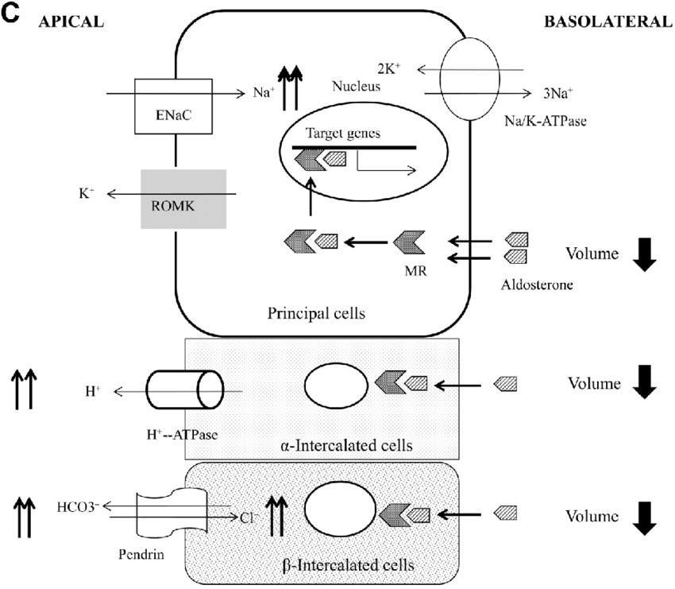
8. **List the various mechanisms that respond to changes in systemic blood pressure.** 
   * Kidneys respond to “effective” circulating volume, not the interstitial fluid where we see edema
   * baroreceptors live on the arterial side of the circulatory system
   * Aldosterone - a cholesterol hormone - so will work on the transcription level and not be so immediate
   * ADH inserts aquaporins (AQP2)
   * 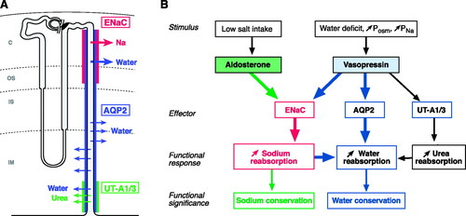
9. **Consider compensatory responses (adaptive and maladaptive) of the body in its effort to maintain circulatory pressure.** 
   * A drop in BP will activate RAAS (hold onto more salt), which might be maladaptive, for example in the case of heart failure that cannot compensate
   * In altered Starling forces, kidney/body effort to restore plasma volume may improve volume deficit somewhat, but also worsen interstitial edema
10. **Explain why sodium saving mechanisms developed during evolution to prevent ECF volume reduction may be activated in disease, causing an increase in the ECF volume above normal.** 
    * in settings of low BP due to some non-renal cause, the **RAAS** system will try to compensate by holding on to salt and trying to increase BP
    * Liver failure case: What are some long-term management strategies for his volume overload: Decreased sodium intake, Aldosterone blockade, Decreased water intake
11. **Describe how sodium is handled along the nephron.** 
    * 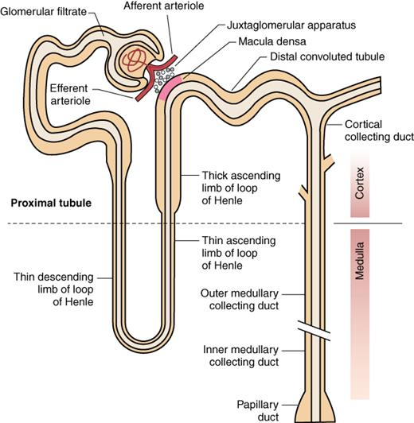
    * Glomerular Filtration Rate (100 mL/min) ~= (150 L/day)
    * ~21,000 mEq/day of Na+
    * Avg American diet: 150 mmol
    * Sodium retention/reabsorption is prominent in heart disease and kidney disease
    * Loop diuretics are the most potent
    * Locations we can act on to pull out sodium
12. **Describe the four major classes of diuretics, their mechanisms of action, their relative potencies, and main side effects.**

|  |  |  |  |  |  |
| --- | --- | --- | --- | --- | --- |
| **Tubule Segment** | **Na Reabsorbed** | **Mechanisms of Na Entry** | **Regulatory Factors (Major)** | **Drugs that target** | **Clinical Utility** |
| **Proximal tubule** | 70% | Na+−H+ exchange; cotransport with glucose, amino acids, phosphate, and other organic solutes | Angiotensin II; norepinephrine; glomerular filtration rate | carbonic anhydrase inhibitor (Acetezolamide)  SGLT2i | CAi - used for contraction alkalosis  SGL2i - hyperglycemia, CKD |
| **(Thick Ascending limb) Loop of Henle** | 20% | Na+−K+−2Cl− cotransport | Flow dependent | Furosemide | drug of choice in CHF, advanced renal failure |
| **Distal convoluted tubule** | 5% | Na+−Cl− cotransport | Flow dependent | thiazide diuretics | good for essential hypertension (less effective if GFR<30) |
| **Collecting tubules** | 1-5% | Na+ channels | Aldosterone; atrial natriuretic peptide | potassium sparing diuretics | adjunctive therapy |

* + Diuretic: has natriuretic and aquaretic properties
    - one of the major reasons for diuretic use is HF - failing ventricle
  + Even though proximal tubules is responsible for most Na+ absorbed, it is not the most potent target (there are many specific ion transporters so you wouldn't be able to target all 70%, and it is so early in the tubule that other transport can compensate for perturbations

1. **Understand the main side effects of diuretics based on mechanisms of action.** 
   * PT Diuretics
     + **Acetezolamide**: carbonic anhydrase inhibitor in PT, **side effect:** low bicarb~acidosis
     + **SGLT2 inhibitors (gliflozins):** blocks reabsorption of glucose through cotransporter of Glu/Na+, not really used as a natriuretic, **side effect:** ketoacidosis, UTI, yeast infections
   * Thick Ascending limb “loop diuretics”
     + **Furosemide (Lasix)**: Blocks Na+K+2Cl− cotransport, **side effect:** low K+, high bicarb
     + first line option for heart failure: use for increasing ECF, reduces fluid overload (but not really used for HTN)
   * DC tubule
     + **Thiazides**: Na-Cl transporter inhibitor–hydrochlorothiazide
       - Patients on thiazide diuretics may experience a **hypokalemic metabolic alkalosis** due to the increase in aldosterone-mediated K and H ions excretion in the intercalated cells of the CT
       - first line use for hypertension
   * Collecting duct
     + **Spironolactone**: aldosterone antagonists
     + **Amiloride & Triamterene:** Na *channel* blockers
       - side effects: high K, low bicarb
2. **Describe how glomerular filtration produces fluid which is then processed by the**

**tubules to make urine.**

* + The kidney’s 3 roles: filtration, reabsorption, secretion
  + GFR does not account for reabsorption or secretion, but we assume they are related
  + The ECF volume gets filtered 10 times a day
  + small molecules goes straight through the glomerulus, proteins do not make it through the glomerulus

1. **Calculate clearance as a measure of the function of a fluid-cleaning machine.** 
   * To measure the GFR look at a molecule that is directly filtered out (not reabsorbed or secreted)
   * We used to use inulin, now we use creatinine (Cr) as a marker of GFR
     + Creatinine is made as a constant rate by our muscles (males 20-25 mg/kg/day, females 15-20 mg/kg/day) goes up with muscle mass and eating meat
     + Assume someone produces 1400 mg/day of creatinine (1 mg/min), assume that rate of filtration is constant, and you need to remove all of it that is produced
       - you can do a timed urine & collect all the urine that someone produces in 24 hr to measure total creatinine amount
     + Clearance = urinary removal rate / measured plasma concentration
     + Clearance = 1 mg/min / (1 mg/dl)
2. **Recognize that the glomerular filtration rate (GFR) provides the single most useful index of kidney function.** 
   * GFR is the amount of plasma filtered by the kidney every minute (mL/min)
   * 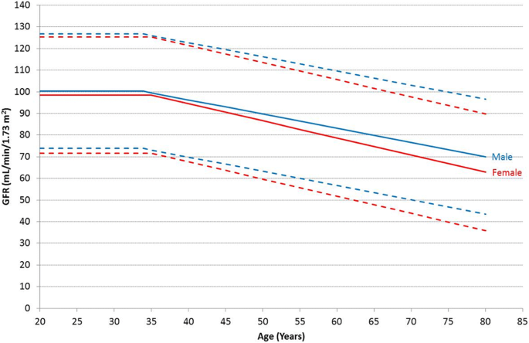
   * Normal ~100 mL/min, declines with age
3. **Explain how the clearance of creatinine is used to estimate the GFR.** 
   * reduced GFR will cause plasma [Cr] to be elevated
   * Calculation is essentially C1V1 = C2V2
     + more precisely CplasmaVplasma/time = CurineVurine/time
     + **GFR = Vplasma/time**
   * If you have 24 h urine values
     + **GFR = [Cr]urine * Uvol/day / ( [Cr]plasma * 1440 min/day)**
     + **GFR = [Cr]urine * Uvol/day / ( [Cr]plasma* 1440 min/day)**
     + remember 1440 min/day
     + Don’t forget to correct units [Cr]plasma is given in mg/**dL** s (1 dL = 100 mL = 0.1 L)
4. **Explain how the plasma concentration of creatinine can be used to estimate the GFR without the need for a timed urine collection.** 
   * clinically eGFR (estimated GFR) is predicted by plasma creatinine concentration and body weight, i.e. for 70 kg person ~ 1400 mg Cr produced per day ~= 1 mg/min
   * in nonstandard conditions (very muscular person, person with missing leg, etc) get 24hr Cr values
5. **Explain how creatinine production is similar despite a decrease in glomerular filtration rate.** 
   * the removal rate is not dependant on clearance - the amount of creatinine in the urine over a 24h collection will be the amount that they made that day regardless of GFR if you are in steady state
     + steady state is where input = output, we assume we are at steady state unless there has been a recent perturbation
   * filtered load = PCr * GFR
     + just the particles directly filtered into bowman’s space, not accounting for reabsorption or secretion
   * Excretion = filtered load - absorbed + secreted
6. **Explain how two individuals with the same solute intake (e.g. sodium, potassium, or phosphate) can demonstrate similar urinary excretion of that solute despite differences in reabsorption rates.** 
   * ?
7. **Apply the steady-state principle to explain physiological phenomena such as salt-sensitive blood pressure or hyperkalemia in chronic kidney disease.** 
   * Most people can eat a high sodium diet and their BP will quickly normalize, but “salt-sensitive” people do not trigger the compensation mechanisms until a higher BP and will not normalize BP based on their compensatory mechanisms
8. **Recognize the physiologic importance of potassium (K+).** 
   * Plasma K+ concentration sets the resting membrane potential of cells
   * K+ levels impact nerve conduction and muscle function
   * Na+K+ ATPase is expressed on all cells, all cells use a majority of their energy to keep the Na+K+ potential
     + Na+ is the predominant extracellular cation [Na+]intracellular = 10, [Na+]extracellular = 142
     + K+ is the predominant intracellular cation [K+]intracellular = 140, [K+]extracellular = 4
   * 2 K+ in 3 Na+ out
   * 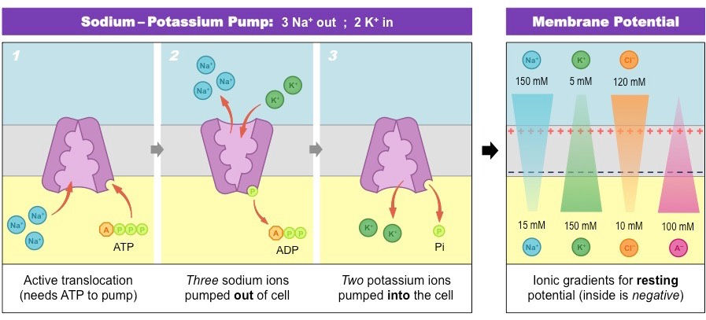
   * The membrane is more permeable to K (100 fold higher than Na) so K+ is always leaking out because the inside should always be negative
9. **Describe the distribution of K+ in the body and its regulation.** 
   * **aldosterone** increases urinary Na & potassium secretion → hypokalemia
   * Insulin → ↑ K+Na+ATPase activity → ↓ plasma K+ **HYPOKALEMIA**
     + Insulin pulls K+ into the cells (postprandial we want to keep consumed K+ low)
   * Catecholamines → ↑ K+Na+ATPase activity → ↓ plasma K+ **HYPOKALEMIA**
     + Beta2 signaling
     + the thought is that exercise releases K+ from the muscles, catecholamines (epi, norepi) pull K+ back into cells to keep K+ extracellular levels low
   * Alkalosis → H+ is pumped out of cells, K+ is pulled into cells → ↓ plasma K+ **HYPOKALEMIA**
     + To maintain electro-neutrality, potassium moves from plasma to the intracellular location. Therefore, alkalosis can often present with hypokalemia.
     + Hypokalemia is not a result of Na+K+ pump regulation, but a result of ion potential
   * Acidosis → H+ is pulled into cell, K+ is pumped out → ↑ plasma K+ Hyperkalemia
     + Less K+ uptake in the setting of an acidosis because bicarb is used up
     + as proton concentrations increase, bicarb is used up and K+ becomes dysregulated
10. **Describe the urinary excretion of K+ and its regulation.** 
    * In the **proximal tubule** K+ is reabsorbed passively by solvent drag
      + 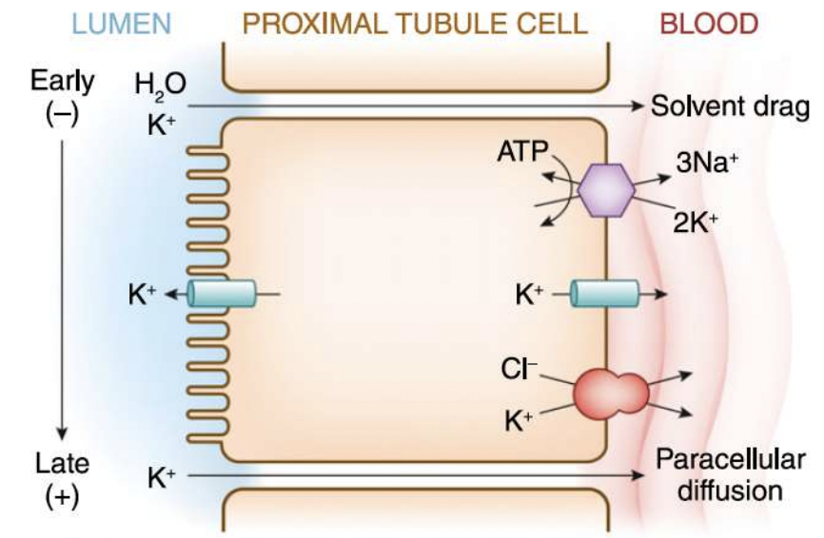
    * in the **thick ascending limb** there are 2 pathways that K+ can be reabsorbed
      + K+CL2-Na+ carrier
      + Paracellular pathway
      + 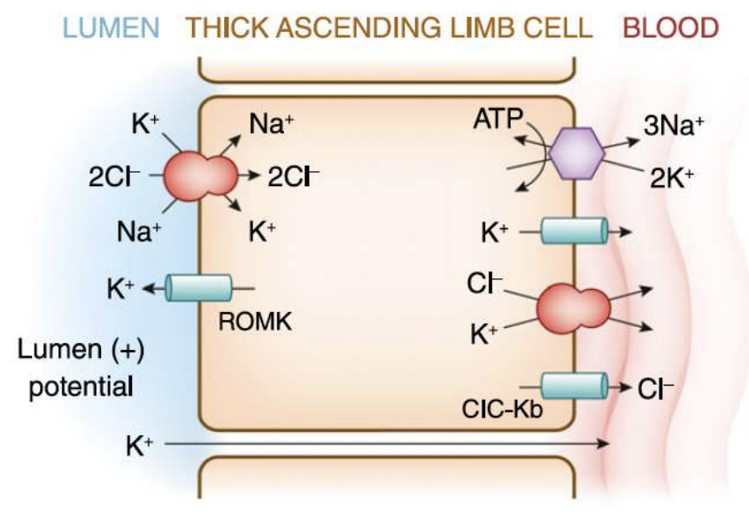
    * In the **distal convoluted tubule**
      + K+ secretion in the distal tubule is dependent on three factors: 1) delivery of Na+; 2) delivery of tubular fluid; and 3) plasma aldosterone concentration
      + 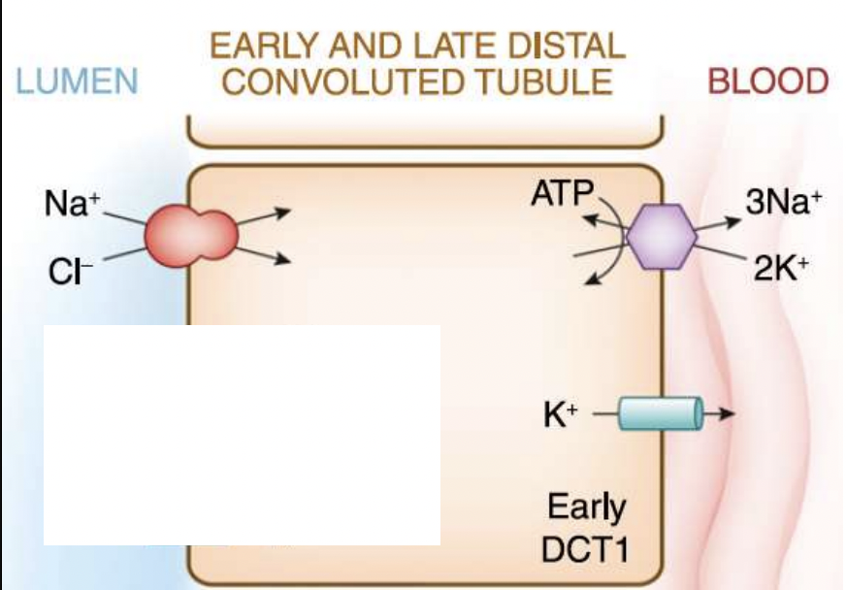
    * In the **cortical collecting duct**
      + In the principal cell: to excrete K+ here you need 1) enough Na+ brought into the cell, and 2) aldosterone
      + 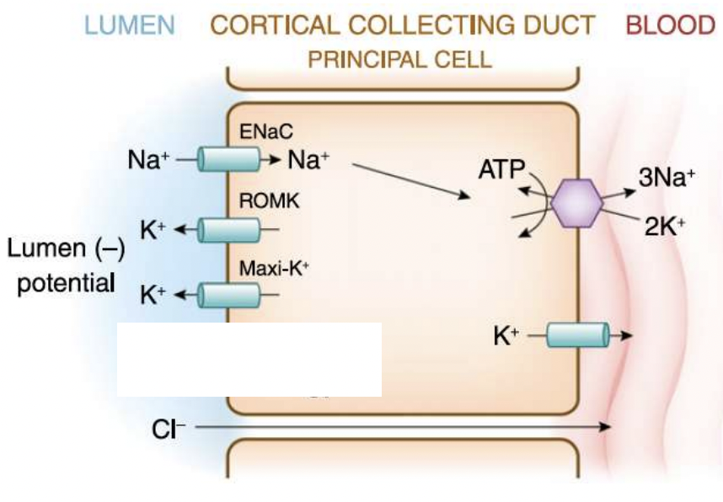
      + In the alpha intercalated cell: Cell important for acid-base balance, but it is also sensitive: 1) Aldosterone can also enhance H+ pump activity 2) Lumen negative potential can also influence H+ excretion
      + 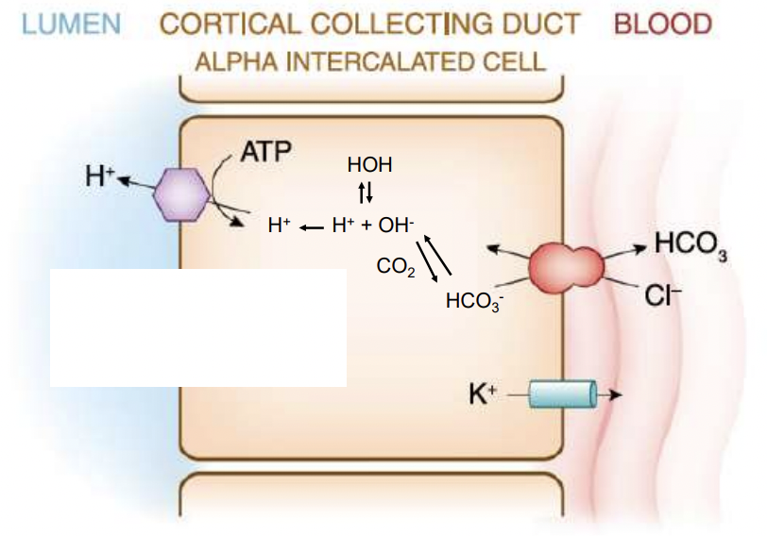
11. **Recognize hypokalemia and describe approaches to its treatment.** 
    * Hypokalemia: <3.5 mEq/L
    * Causes:
      + **Poor oral intake**: starvation, vomiting, malabsorption
      + **Shifting too much into cells**: Insulin overdose (insulinoma, exogenous, hyperthyroidism [*TH increases insulin sensitivity*]), stress reaction (catecholamines), alkalosis (TUMs)
      + **Increased stool loss**:
        - diarrhea, laxative abuse, tumors [villous adenoma] that cause K+ excretion in stool [via VIP]
      + **Increased urine loss**:
        - increased water in the distal tubule. This will activate BK (potassium) channels in the principal and intercalated cells to induce K+ secretion.
        - the volume depletion → Aldosterone stimulation → activates ENaC in the principal cell → increase electrogenic Na+ reabsorption and increase the negative lumen potential → favors K+ secretion into the urine
        - Diuretic medications thiazides **Ethacrynic acid** & loop diuretics like **Furosemide** → ↓ K+ (principal cell is being stimulated too much, K+ is being over secreted)
        - Mineralocorticoid excess (i.e. aldosterone secreting adrenal adenoma, hyperreninism from renal artery stenosis)
        - Amphotericin B
        - Hypomagnesemia
12. **Recognize hyperkalemia and describe approaches to its treatment.** 
    * Hyperkalemia: K+ >5.5 mEq/L
    * Usually asymptomatic until arrhythmia (Peaked T waves, PR prolongation, QRS widening, Sin wave formation)
    * **Causes:**
      + excessive oral intake is rare - Difficult to ingest enough K to overwhelm the kidney: hot dog as an example
      + Excessive shift of K+ out of cells - Insulin deficiency, Adrenergic blocking medications, Acidosis, Cell lysis (rhabdo, tumor lysis, bowel ischemia, crush trauma)
      + Stool excretes only K+ 10-20 mEq/day, and intake 70-100 mEq, stool retention is not major cause of hyperkalemia, Kidney problems major cause
      + Urine retention of K: Renal failure, Hypoaldosteronism, Potassium sparing diuretic such as Spironolactone
13. **Identify normal urinary bladder and prostate histology.** 
    * Urinary Bladder Outline
      + 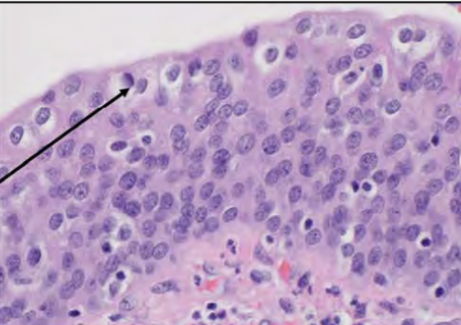Mucosa: Transitional epithelium (urothelium) 5-7 cells stacked, square looking cells with large nuclei that can deform to be flatter when stretched (most superficial are called “umbrella cells” because they deform the most), forms non-permeable layer to keep toxic urine away from cells with specialized desmosomes
        - squamous metaplasia in bladder is more common in trigone (especially in women who get frequent UTIs)
      + 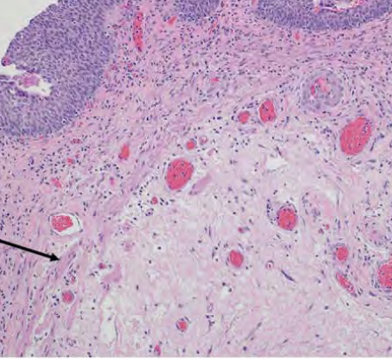Lamina propria: connective tissue, discontinuous muscle fibers
      + 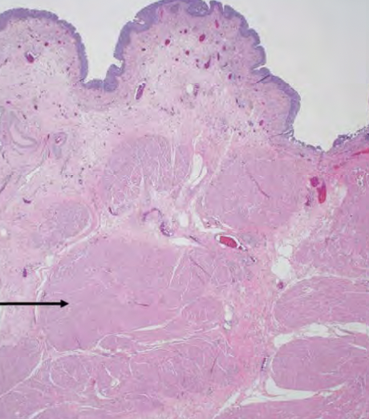Muscularis propria (detrusor muscle): muscular, eosinophilic, muscle fibers are in several different directions to squeeze bladder in all directions
      + adventitia-serosa (thin layer on outside) on top the peritoneum
    * Ureter Outline
      + Mucosa: transitional epithelium “urothelium”, ureters can expand significantly in case of blockage
      + Lamina propria
      + Muscularis propria - peristalsis of fluid down ureter
      + adventitia-serosa 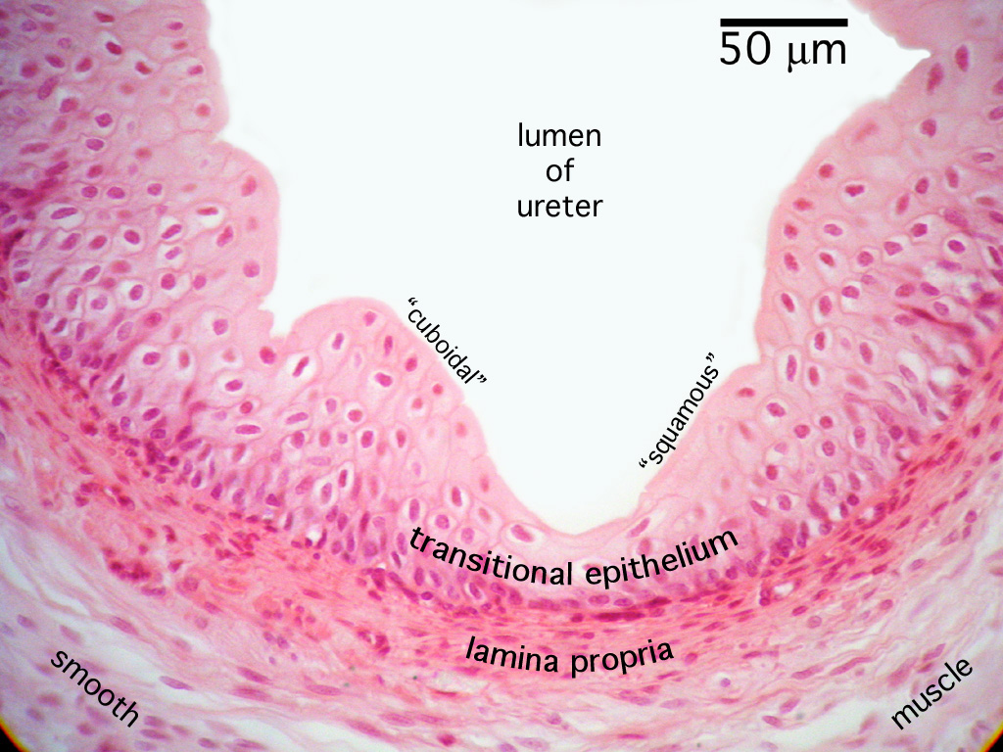
    * Prostate Outline:
      + 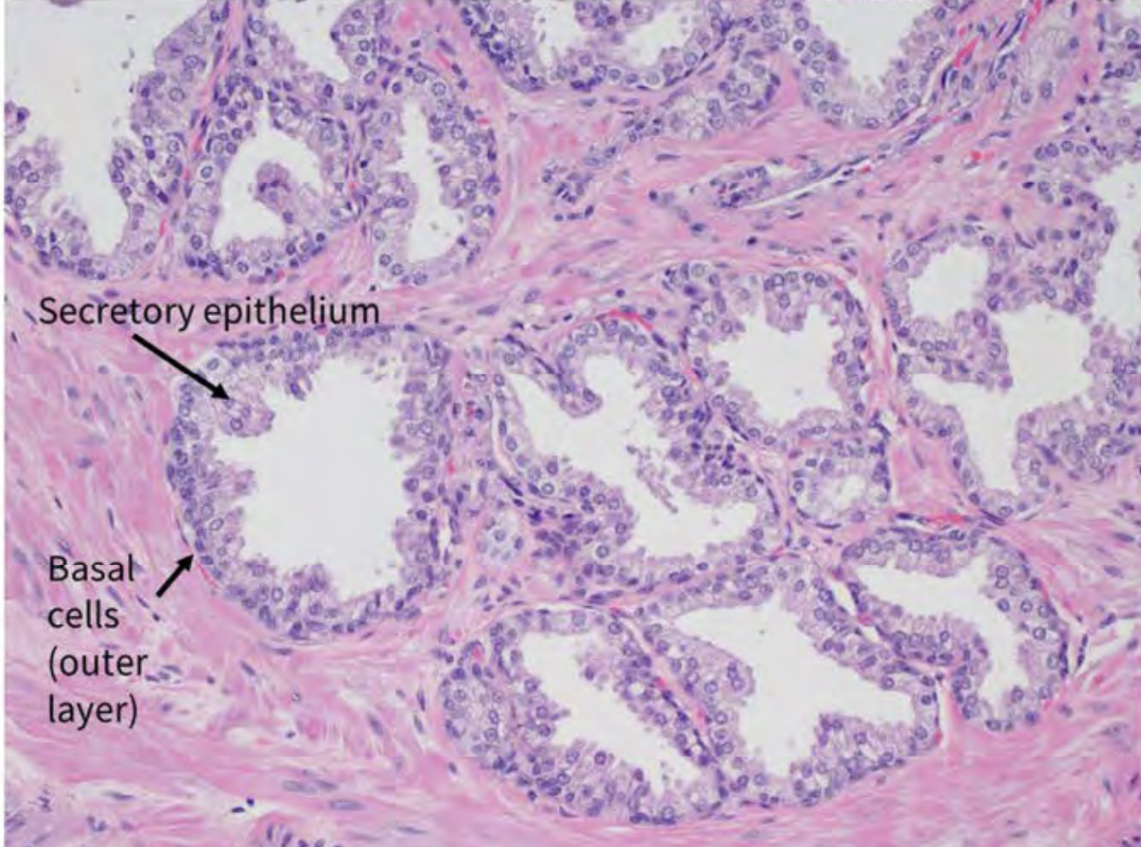
      + low-power organization “lobular glands in fibromuscular stroma”
      + Epithelium: Basal cell & secretory epithelium
    * seminal vesicle:
      + 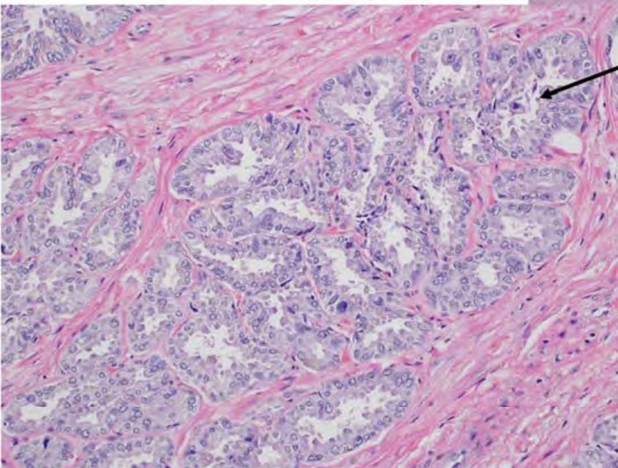
      + highly coiled ducts surrounded by muscular wall (relative to prostate is more coiled and has higher amount of pleomorphism)
14. **Identify normal kidney histology.** 
    * Review kidney anatomy (outer capsule > cortex > medulla > pelvis > ureter)
    * Cortex: has glomeruli & tubules vs. medulla: only tubules
    * 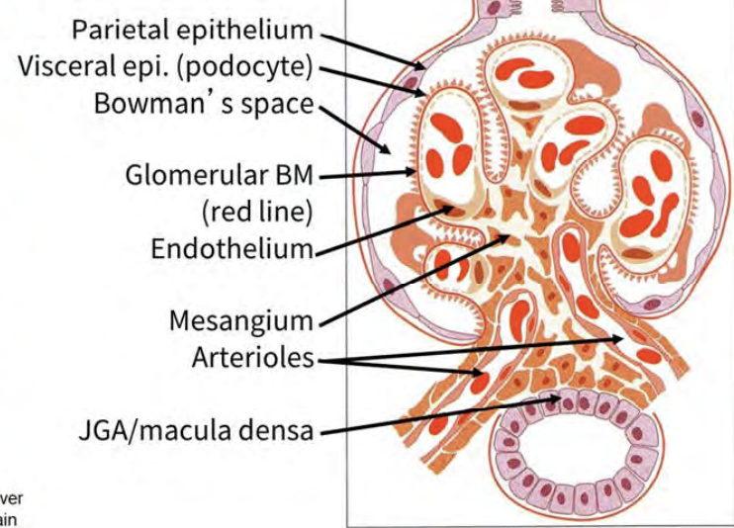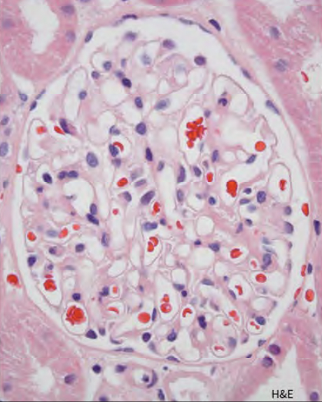Glomerulus anatomy: basically a balled up capillary (specialized endothelial with fenestrations), covered in podocytes(visceral epithelium), mesangial cells hold capillaries together, bowman's space is where urine is collected, bowman's capsule (parietal epithelium) surrounds bowman's space, JGA touches macula densa in distal convoluted tubules
15. **Describe normal glomerular microanatomy, and how pathologic changes are evaluated.** 
    * Glomerulus: normal barrier between urine and blood is podocyte (slit diaphragm between little toes) + glomerular basement membrane (GBM) + fenestrated endothelium.
      + 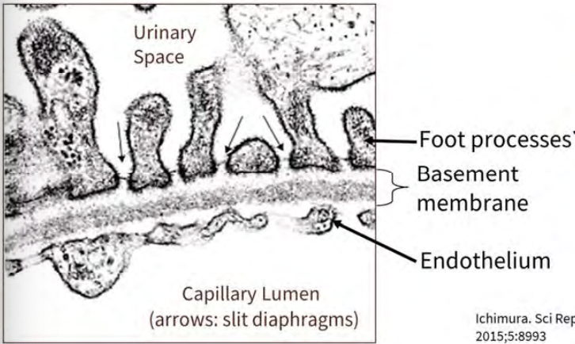
      + Podocytes keep protein in blood in **Minimal change disease**: podocytes fused together and clinically detected as massive protenuria
        - 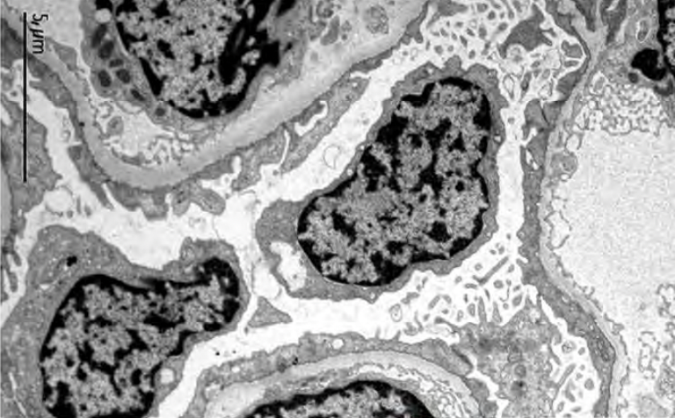
      + GBM is negatively charged keeps in **Alport syndrome:** the lamina densa is thickened & has subepithelial scalloping due to mutations in type IV collagen, causes microscopic hematuria & proteinuria
        - 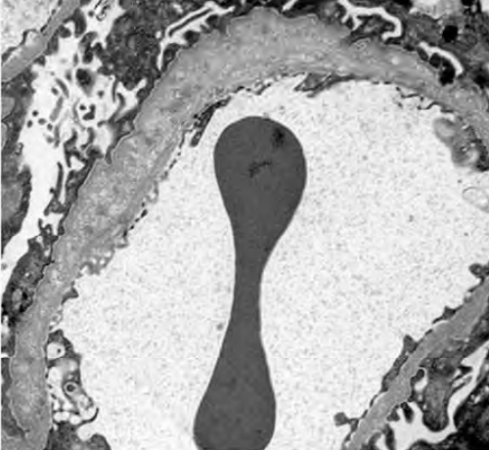
    * Tubules: distal tubules have less cytoplasm, are more flat than thick proximal tubules 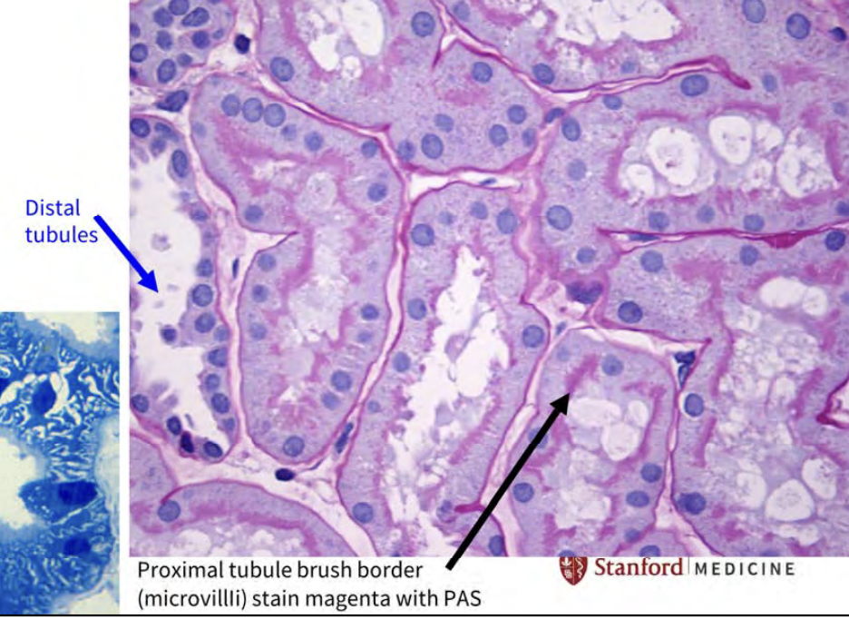
      + can't really distinguish the exact parts of the nephron based on tubule characteristics alone (aka don't worry about it ~tubes are tubes)
    * Juxtaglomerular apparatus
      + senses the urine in the distal tubule after all reabsorption and can modulate the arterial side with renin
    * Uroepithelium is seen at each papilla at the deep medulla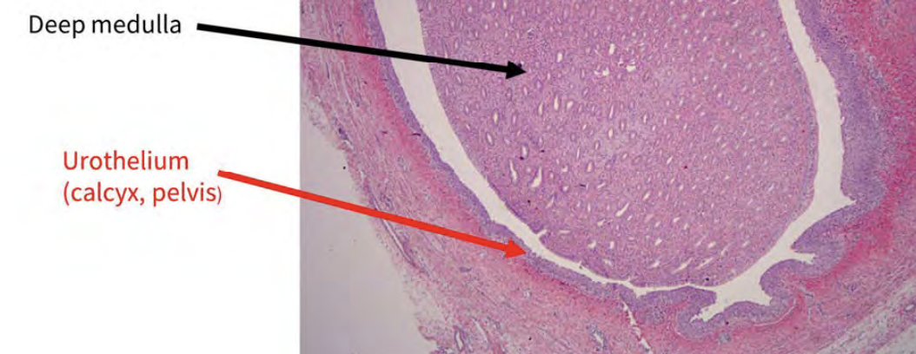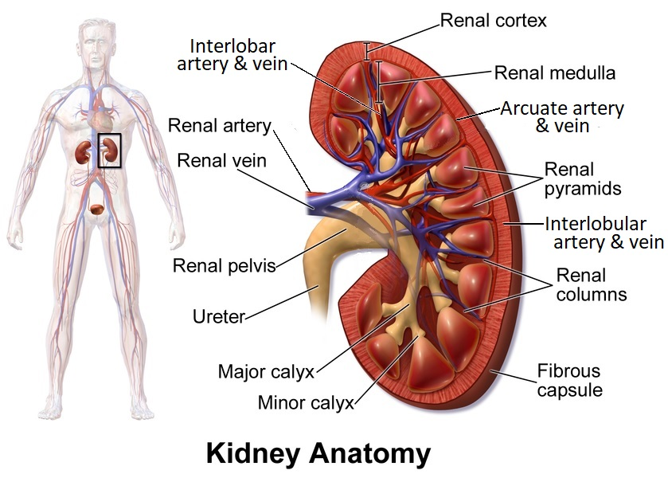
    * Renal artery → segmental arteries → interlobar artery → arcuate artery → cortical radiate arteries (aka interlobular arteries) → afferent arteriole → glomerulus → efferent arterioles → vasa recta → interlobular veins
    * **Lupus nephritis** - “full house” on immunofluorescence showing circulating immune complexes - positive staining of IgM, IgA, IgG in glomerulus
    * Acute injury signs - mesangial proliferation, fibrinoid necrosis, cellular crescent, endocapillary proliferation
    * chronic kidney signs - sclerosis of glomeruli, fibrous crescents, glomerular tuft adhesions, tubular atrophy (all irreversible)
16. **Recognize that H+ is buffered to keep its concentration very low.** 
    * we keep a very low amount of free H+ ions in the body, because proteins would be nonfunctional at slightly different pH values (remember amino acid pKa values)
    * without a buffering system tiny amount of [H+] would ruin the body
    * HCO3 is the major buffering system in the body, but proteins and other ions can also buffer
17. **Recognize that the H+ concentration is expressed as its log, the pH.** 
    * Bicarb buffering system - think of le chatelier to solve problems with this
      + H+ + HCO3- ←→ H2CO3 ←→ H2O + CO2  (assisted by carbonic anhydrase)
    * pH = -log([H+]) = pKa + log([base]/[acid])
18. **Recognize that H+ can be produced and consumed by metabolism.** 
    * CO2 and H+ (lactic acid) are produced via glycolysis
19. **Understand that there has to be a buffer which reacts with ("buffers") H+.** 
    * A buffer for H+ is a weak base that can easily take/give an H+
      + buffer examples: HCO3, NH3, proteins
20. **Describe the equilibrium equation for the bicarbonate buffer system; H+ concentration is determined by HCO3- concentration and pCO2.** 
    * From clinical values, use the PCO2, and pKa for carbonic acid
    * pH = 6.1+log([HCO3-]/(0.30*PaCO2)
      + pH = 6.1 + log(metabolic/respiratory)
    * pCO2 = 1.5*[HCO3]+8

|  |  |  |  |  |
| --- | --- | --- | --- | --- |
|  | **pH** | **H+ (nEq/L)** | **PCO2 (mmHg)** | **HCO3− (mEq/L)** |
| **Arterial** | 7.37–7.43 | 37–43 | 36–44 | 22–26 |
| **Venous** | 7.32–7.38 | 42–48 | 42–50 | 23–27 |

1. **Understand that the HCO3- buffer system is an “open system”.** 
   * The lungs can breathe off CO2 so this makes the eq shift right
   * H+ + HCO3- ←→ H2CO3 ←→ H2O + CO2
   * the coincidence rule states that if the lungs are compensating - the pCO2 should match the last 2 digits of the pH - then it is a “simple acidosis”
2. **Understand how the kidneys regulate bicarbonate by urine acidification.** 
   * the proximal tubule is responsible for bicarbonate reabsorption
     + H+ is excreted through H+/Na+ exchanger
     + H+ binds to HCO3 in the tubule
     + H2CO3 is formed and converted by carbonic anhydrase (CA) to H2O and CO2
     + CO2 dissolves into the cell and CA forms new bicarbonate inside the cell
   * Bicarbonate can only buffer small amounts of H+ in the kidney
   * NH3 buffers the most H+ in the urine
3. **Understand the causes of "metabolic acidosis".** 
   * respiratory - starts with change in PCO2
     + Acidosis - due to some defect in the ventilation of the patient
       - CNS respiratory drive (drugs, sedatives, opiates, etc., obesity)
       - Respiratory muscles/chest wall (ALS, polio, myasthenia gravis)
     + Alkalosis - due to
       - CNS (liver disease, sepsis, pregnancy [progesterone], stroke]
       - pulmonary disease (hypoxemia, pneumonia, high altitude, CHF)
   * metabolic - starts with change in HCO3-
   * Simple acidosis/alkalosis = one process
4. **Recognize that the metabolic alkalosis is maintained by the excretion of excess H+ by the kidney in an effort to retain sodium, which keeps the bicarbonate concentration above normal.** 
   * if pH and bicarb are high → metabolic alkalosis
   * if pH is high and pCO2 is low → respiratory alkalosis
   * kidney loses H+ while trying
5. **Explain how the anion gap is used to distinguish the two categories of metabolic acidosis.** 
   * anion gap is the unmeasured anions (we measure Cl-, HCO3-, SO4-, PO4-, proteins, organic acids)
     + Anion gap = Na+ - Cl- + HCO3-
     + anion gap <12 is no anion gap
     + essentially the fingerprint of abnormal acid that is added to the ECF space by the body
6. **Apply acid-base physiology to identify acid-base disorders.** 
   * 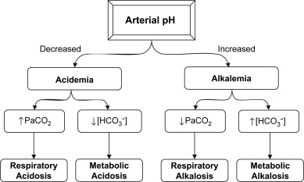
   * Acidosis
     + 4 types of anion-gap acidosis (normal is 10-12) *\*think about abnormal acid being added*
       - lactic acidosis
       - ketoacidosis (acetoacetate)
       - ingestion of acids: salicylates (aspirin), methanol, ethylene glycol
       - renal failure
     + Normal gap acidosis
       - diarrhea
   * Major Causes of Metabolic Alkalosis
     + vomiting (losing acid)
     + Alkali administration (tums)
     + Intracellular shift of hydrogen ion (H+—as occurs in hypokalemia)
       - can be due to high aldosterone ([Na] reabsorption and [K+]&[H+] excretion)
     + Renal HCO3− retention
7. **Understand the burden of kidney stone disease.** 
   * 1:10 people will have a stone at some point in their life
8. **Understand how kidney stones form.** 
   * stones form in supersaturated solutions that start binding to a nidus
   * the exciting factor is thought to be inflammation/injury that leads to a “Randall's Plaque” which is a calcium phosphate crystal on the wall in the uro system
   * microscopy is needed to determine what the stone is made from
   * most are calcium based
9. **Describe the common types of kidney stones and risk factors for each type of kidney stone.**

|  |  |  |  |  |
| --- | --- | --- | --- | --- |
| **Stone type** | **Microscopy** | **Urine Risk Factors** | **Clinical Setting** | **Medical Treatment** |
| **calcium oxalate stones**  o⋈alate | dumbbells (monohydrate)    **envelopes** (dihydrate) | low urine volume, **hypercalciuria**, **hyperoxaluria,** hypo**citraturia,** hyperuricosuria | (80% of stones) | -Thiazides  -potassium citrate  -low-oxalate diet |
| **Calcium phosphate stones** | wedge-shaped prisms | low urine volume, alkaline pH, hypercalciuria, hyperphosphaturia | (5-15% of stones)  women, pH>6.3, iatrogenic cause: topiramate, *acetazolamide* |  |
| **Uric acid stones** | rounded rhomboids or needle-shape | low urine volume, **acidic urine** (meat acidified urine), hyperuricosuria | (3-10% of stones)  rising in prevalence with metabolic syndromes, DM2, obesity (not gout surprisingly) | -urine alkalization  -sometimes allopurinol |
| **Struvite stones** | “coffin lid”  *forms large staghorn stones* | chronic UTIs: *Proteus mirabilis* is the most common pathogen and less common pathogens include *Klebsiella pneumonia*, *Pseudomonas aeruginosa* and *Enterobacter*. | (10-20% of stones)  more common in women |  |
| **Cystine stones** | hexagons | cystinuria  genetic >600 mg/day cystine in urine | (<2% of all stones)  homozygous recessive gene, most common stone in children |  |

* + Hypercalciuria (>200 mg/day) causes:
    - idiopathic: coming from either the gut (Chrons), bone, kidney leak
    - other disease - ex: hyperparathyroidism
  + Hyperoxaluria (>40mg/day) causes:
    - increased dietary intake (dark leafy greens, nuts, chocolate, tea) vitamin C
    - generic problems (Crohn’s, bypass surgery)
  + Hypocitraturia causes (<400 mg/day)
    - diets high in meat are largely acidic
    - TX: potassium citrate
      * citrate binds to calcium to prevent it binding to oxalate
  + High sodium excretion (>3000 mg/day)
    - average american is high in sodium

1. **Understand basic medical and surgical management for kidney stones.** 
   * dietary therapy (drink more fluid, eat less salt (particularly sodium) )
   * medications
     + Thiazides - lowers Ca excretion, extracellular volume contraction
     + Alkali therapy - use for calcium oxalate & uric acid stones
       - potassium citrate, sodium bicarbonate, high citrate lemonade
     + Allopurinol
   * Extracorporeal shockwave therapy (ESWT)
     + used for stones visualized on kidney, ureter, and bladder (KUB) X-ray
   * Ureteroscopy with laser lithotripsy or baskets
     + used for small stones <2cm
   * Percutaneous nephrolithotomy
     + used for huge stones, last resort
2. **Explain the physiological consequences of a rise in tonicity.** 
   * **↑ tonicity** above a certain threshold stimulates hypothalamus to release ADH (vasopressin) & stimulate thirst (controlled by **osmotic sensors** & volume sensors)
     + paraventricular neurons & supraoptic nuclei in the hypothalamus sense osmolality
       - ADH is stored in the posterior pituitary
       - ADH increases water reabsorption through the kidney
       - thirst will increase total body water
   * **↓ tonicity** stimulates hypothalamus to inhibit release ADH (vasopressin) & inhibit thirst
3. **Explain how the kidney is primed to concentrate urine.** 
   * Countercurrent multiplication
   * Countercurrent exchange
4. **Explain how the concentrating mechanism maintains water balance.** 
   * ADH inserts aquaporins to the apical membrane of collecting duct
     + **aquaporin 2** is on the principle cells in the collecting duct - the end effector of pulling water back in and concentrating urine at the end of the nephron
5. **Define serum osmolality.** 
   * Posm = 2Na + glucose/18 + BUN/2.8
   * Effective Posm = 2Na
6. **Review antidiuretic hormone (ADH) release and its actions on the kidney.** 
   * ADH leads to reabsorption of water
   * decreased effective arterial blood volume → Appropriate ADH release
     + (HF, cirrhosis, nephrotic syndrome, volume depletion)
     + the volume sensor is just does what it is told
   * syndrome of inappropriate ADH - tumors (brain, lung adeno)
7. **Define Hyponatremia and discuss causes.** 
   * hyponatremia: <135 mEq/L implies hypo-osmolarity (because sodium is most of what sets the osmolarity of the body)
   * Causes:
     + inappropriate ADH (SIADH), reabsorbs water, dilutes the sodium
     + iatrogenic (thiazide DCT)
       - Loop diuretics (furosemide) does not cause hyponatremia
8. **Define Hypernatremia and discuss causes.** 
   * hypernatremia: >145 mEq/L implies hyperosmolarity
   * Causes:
   * inability to respond to thirst
     + no access to water (baby, coma, alzeimers)
   * kidney losing water: decreased ADH response = **diabetes insipidus** “dilute urine”
     + central diabetes insipidus
       - tumor that disrupts ADH release
       - ischemia of pituitary
         * Sheehan's syndrome, postpartum loss of blood flow
         * trauma to pituitary
       - alcohol
     + nephrogenic diabetes insipidus
       - lithium induced: lithium preferentially goes through ENaC on the principle cells, preventing sodium to signal aquaporins to the surface, leading to decreased ability to respond to ADH (fun fact: amiloride is a ENaC inhibitor)
       - congenital: AVPR2 gene mutation, AQP2 gene mutation
9. **Distinguish between disorders of water and salt.** 
   * volume and sodium can be elevated or reduced/elevated in different directions, every possible combination is possible
10. **Recognize the three main categories of acute kidney injury: pre-renal, intrinsic renal, post-renal.** 
    * “acute” = hours to days (“acute renal failure” is not a thing anymore)
    * “chronic” = more than 3 months
    * Urine Output Definitions:
      + Oliguria: < 0.5 mL/kg/hr (ex: <35 mL/hr for 70 kg patient)
      + Anuria: < 50 mL/day
      + non-oliguric (normal UOP 1-2 L/day)
    * **pre-renal AKI** - low flow into the kidney (renal artery stenosis, etc)
      + high urine osmolality (ADH is increased)
      + usually iatrogenic (diuretics)
      + should be reversible, the renal tissue is not dead unless this has been happening for a long time, but can lead to ATN
    * **intrinsic renal AKI** - damage to the parenchyma (vascular, glomeruli, tubules, interstitial)
      + afferent/efferent arteries
        - prostaglandins dilate afferent arterial
        - NSAIDs contract afferent arterial
        - ARBs & ACEs dilate both afferent and efferent arterioles
        - angiotensin II contracts efferent
      + Glomeruli
        - glomerulonephritis, diabetes, amyloidosis, thrombotic microangiopathy
      + acute tubular necrosis (ATN) → urine casts (due to necrosis of tubules from poor blood flow or toxin)
        - 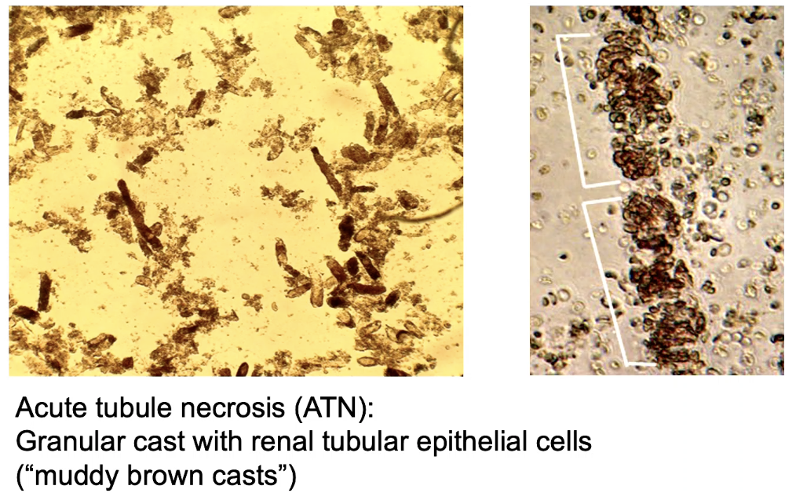
        - toxins - aminoglycosides, rhabdomyolysis [crush injuries] , myoglobinuria
    * **post-renal AKI** - anything that causes a blockage in the urinary tract & backs up urine
      + anything that leads to hydronephrosis: stones, prostate enlargement, retroperitoneal abdominal or pelvic mass, congenital anomalies UVJ
11. **Understand the diagnostic approach of acute kidney injury.** 
    * high creatinine and low urine output (UO) are the first sign, but you need to know the baseline creatinine to differentiate from chronic kidney disease (CKD)
    * **creatine** & **UO** & **BUN** can describe the severity of the AKI
    * **urine [Na]** and **FENa** (fractional excretion of Na) can help you understand what is going on
    * check for casts (indicates intrarenal issue)
    * 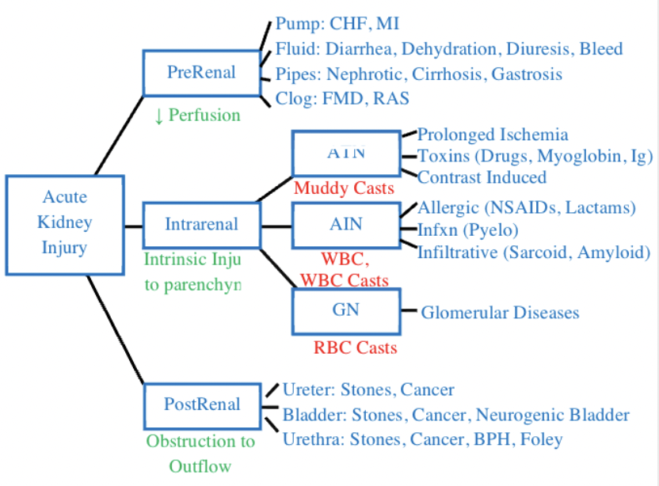
12. **Describe the management of acute kidney injury.** 
    * relieve obstruction if found
    * optimize renal perfusion (IV fluids, vasoactive meds)
    * minimize renal toxins (NSAIDs & iodinated contrast)
    * treat underlying cause (infection of glomerulonephritis)
    * “renal dose” medications, follow guidelines on lower doses of drugs to use if clearance is down
    * consider dialysis
      + indications: (AEIOU) acidosis, electrolyte imbalance [K], intoxication/ingestion, overload volume, uremia

**_________________________________MIDTERM___________________________________**

1. **Discuss the epidemiology, clinical presentation, histopathology, and treatment of the common types of bladder cancer.** 
   * Most common bladder cancer is urothelial cancer
     + **Epidemiology:** older age (peak in 60s), males, smoking, occupational exposure (dyes, chemicals, paints)
     + **Clinical presentation:** hematuria
     + **dx:** is usually with cytology of the urine can be used to see signs of malignancy
       - 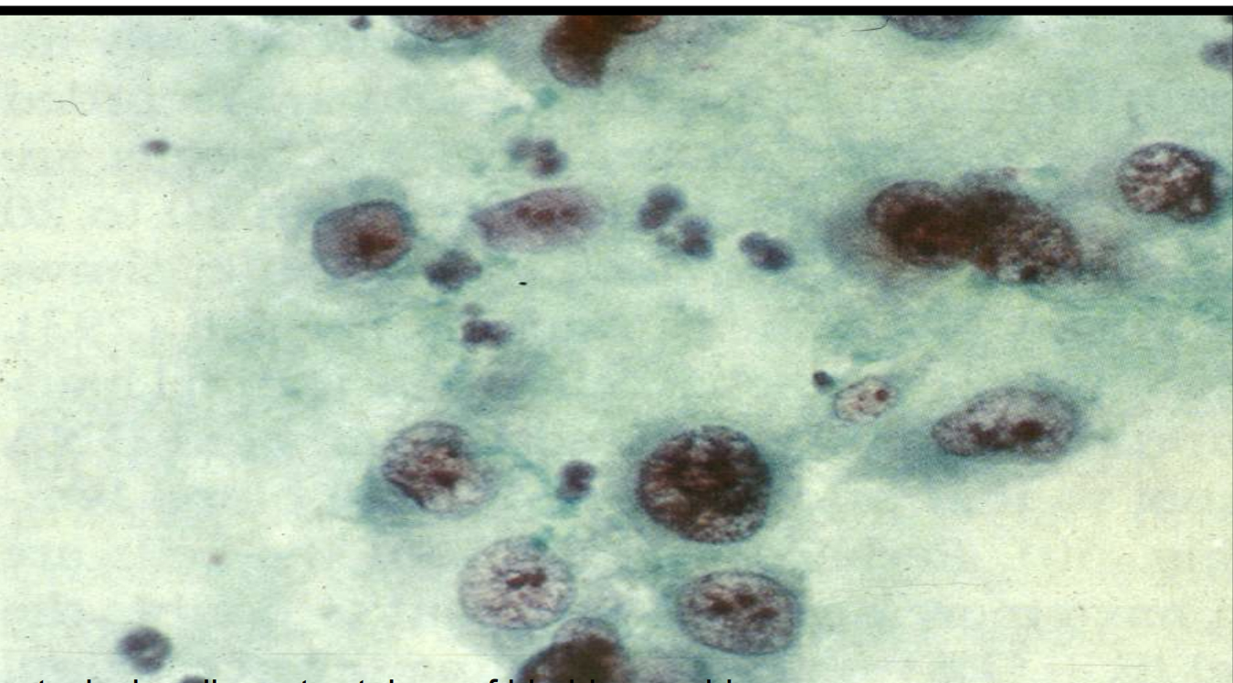
       - large nuclei, hyperchromatic, pleomorphism, mitotic figures, high NC ratio
     + **Histopathology**:
       - non-invasive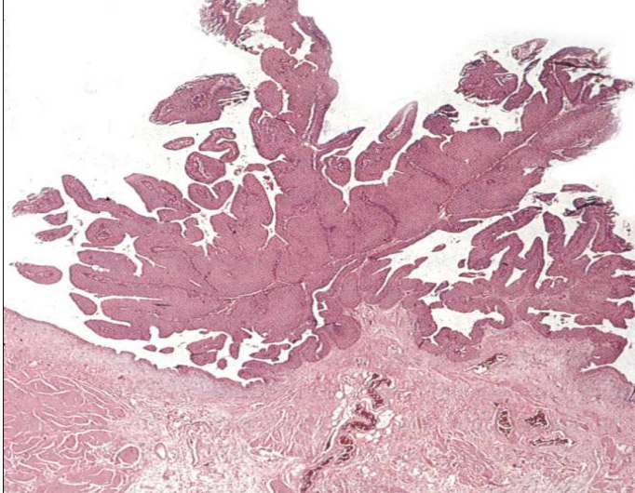
       - invasive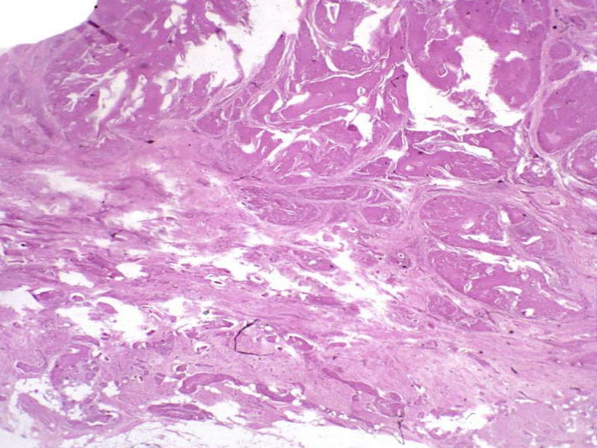(lo res)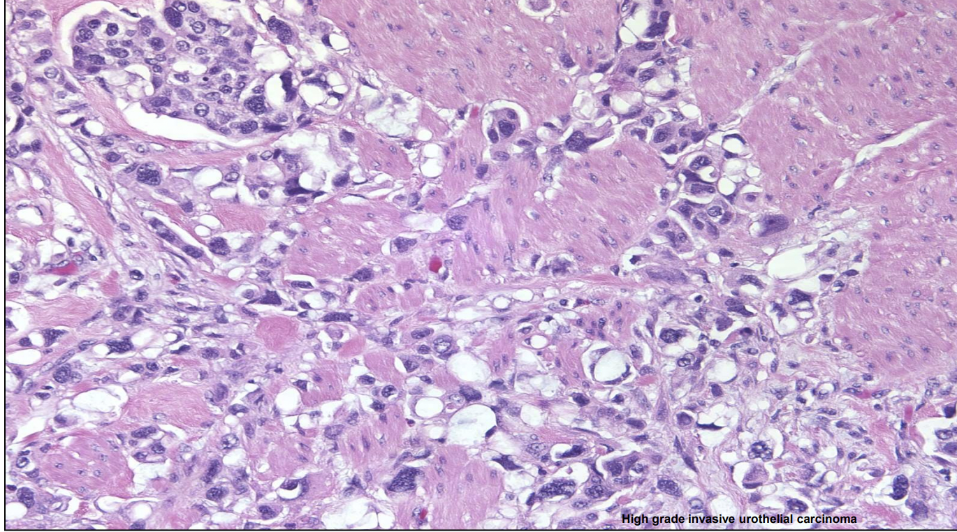 (hi res)
       - Need biopsy to see architecture, determine if it is invading past the epithelium
         * carcinoma in situ: must also be flat (not papillary) and high grade
         * different in situ distinction than in other organs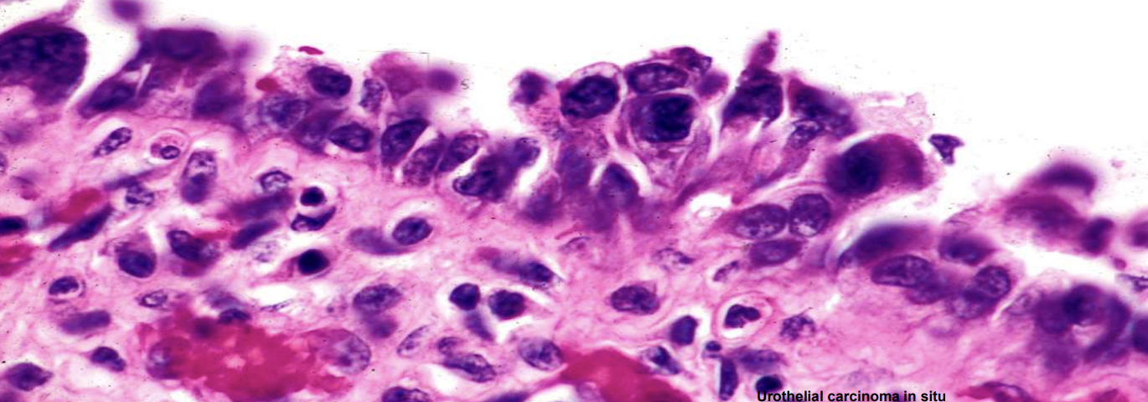
     + **Tumor characteristics:** can be anywhere there is urothelium, from the renal pelvis to urethra
     + **Treatment:** excision, intravesical chemo, BCG
   * can see squamous cell bladder cancer (look for keratin pearls)
     + usually due to schisto infection or chronic indwelling catheter
     + 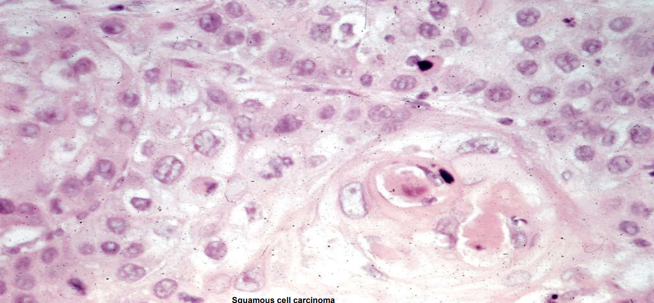
   * can see adenocarcinoma in the bladder
     + look for glands
2. **Discuss the epidemiology, clinical presentation, evaluation, and treatment of the most common neoplasms of the kidney.** 
   * Renal cell carcinoma “clear cell” carcinoma
     + **Histopathology:** boxy clear looking cells, grossly yellow because they have alot of lipids in them
     + 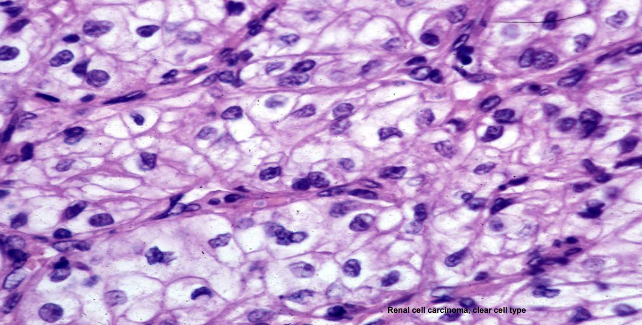
     + **Epidemiology:** >40y, von whipple lindaus
     + 5y OS: 40%
     + **Presentation**: flank pain, hematuria, flank mass (usually already advanced)
   * Papillary renal cell carcinoma
     + still from the epithelium
     + 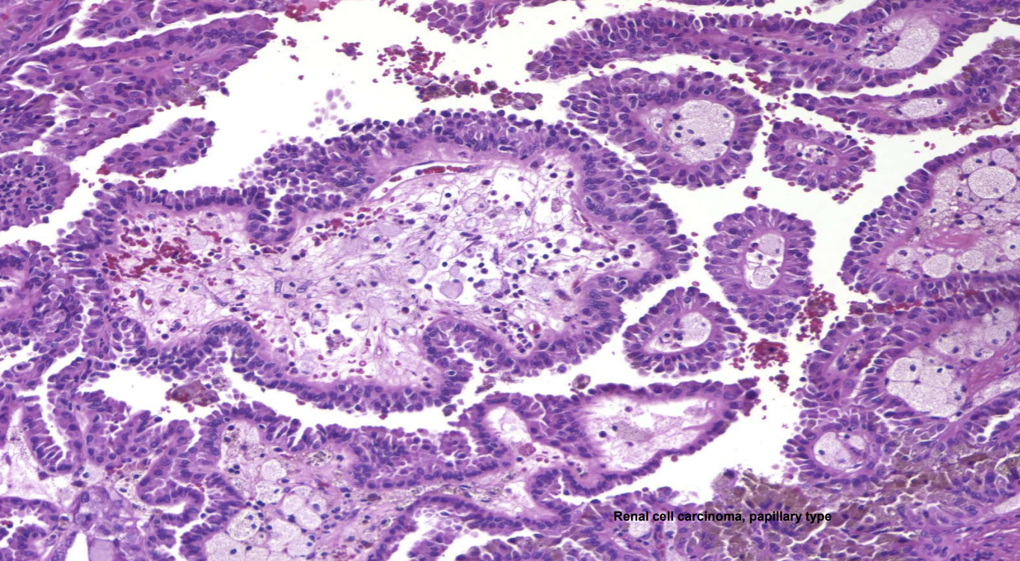
   * Sarcomatoid renal cell
     + stick together
     + 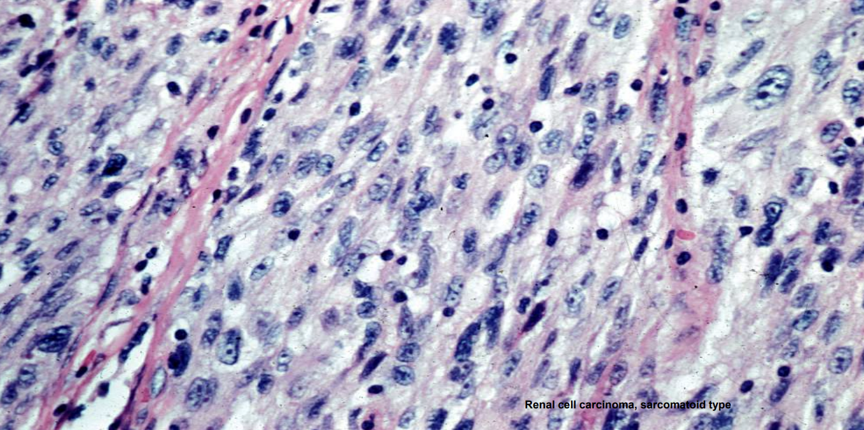
   * Renal cell tumors can grow into vena cava, have endocrine effects
   * Renal cell adenoma
     + usually small and asymptomatic
   * Renal Oncocytoma - benign = no mitotic figures
     + nuclei are large like malignancy, but stay benign
   * Angiomyolipoma
   * **Tumors in childhood**
   * Wilms' Tumor (Nephroblastoma)
     + Histology: Combination of three elements: epithelial tubules, cellular stroma, and undifferentiated “blastema”
     + 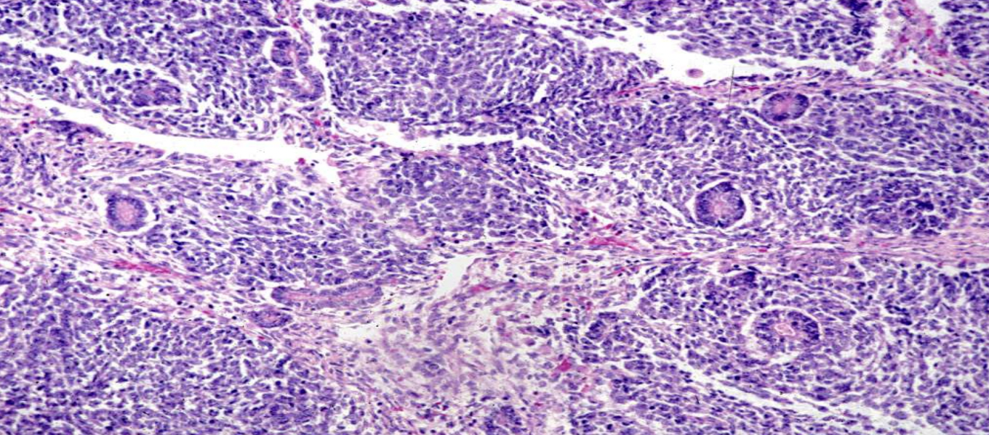
   * Mesoblastic nephroma, congenital to first 6 months of life
     + Tumor of early infancy: rarely in older children
     + Trabeculated appearance similar to uterine leiomyoma
     + Interlacing fascicles of bland spindle cells; hypercellular zones may resemble sarcomatoid Wilm’s tumor. Only rare recurrences after surgical removal
   * Embryonal Rhabdomyosarcoma
     + (sarcoma botryoides) most common soft tissue tumor of childhood with 20% occurring in the genitourinary tract
     + 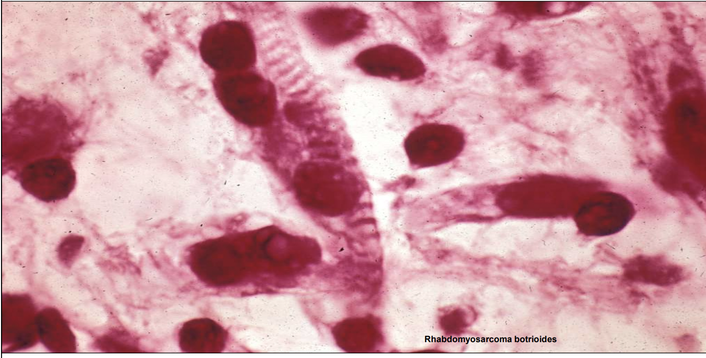
3. **Recognize the radiographic features that distinguish benign from malignant cystic lesions in the kidney.**
   * Incidental finding of renal cysts get sorted by radiologic features (Bosniak classification)
     + Class I Bosniak: simple cyst, hairline thin wall, water attenuation, no calcifications, common finding
     + Class II Bosniak: microcalcifications, some septae
     + Class IIF Bosniak (F for requires follow-up re-imaging)
     + Class III Bosniak: some calcifications, septae not quite (refer to surgeon for removal)
     + Class IV Bosniak: >4 cm, calcification, neovascularization, soft tissue features “meaty” (refer to surgeon for removal)
   * 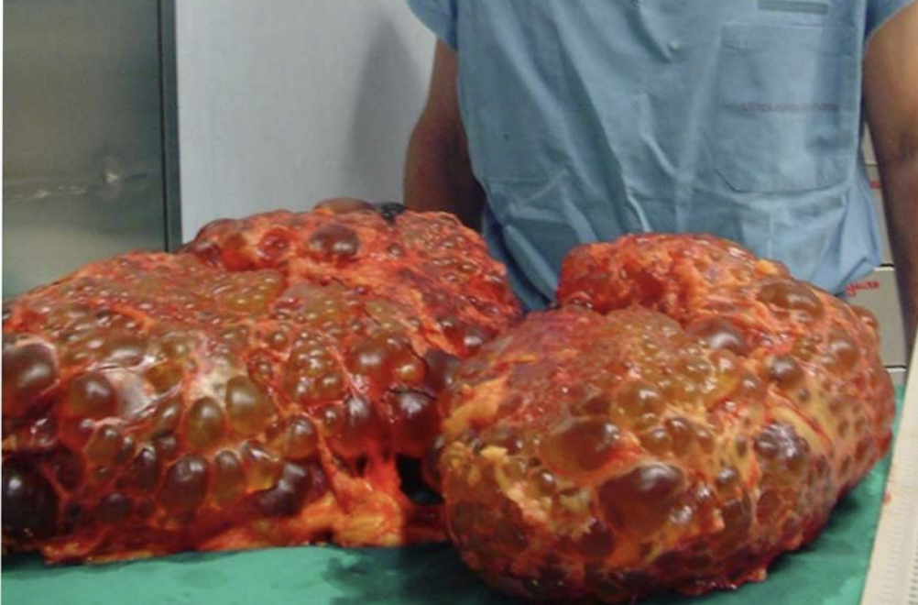
4. **Generate a differential diagnosis for cystic disease of the kidney.**
   * can be benign (simple cyst that does not change) or PKD
5. **Understand the epidemiology and inheritance patterns of the most common cystic kidney diseases.**
   * Polycystic kidney disease (PKD)
     + “ADPKD” due to mutation in genes PKD1, PKD2, PKHD1 - autosomal dominant disease
       - common 1/500 people
       - typically develop by age 50
     + the juvenile disease forms are mostly autosomal recessive though
     + ADH → cell proliferation in the kidney and cyst formation in PKD
       - could give ADH antagonist drug Tolvaptan
       - encourage to drink lots of water to keep ADH low
6. **Review the basic structure and function of the normal glomerulus.** 
   * Systematic assessment of the kidney - Check the glomerulus, tubules, and interstitium, blood vessels for different disease processes
   * In renal path, you may need to look both LM, IF (to see immune deposits), SEM (to see podocytes) 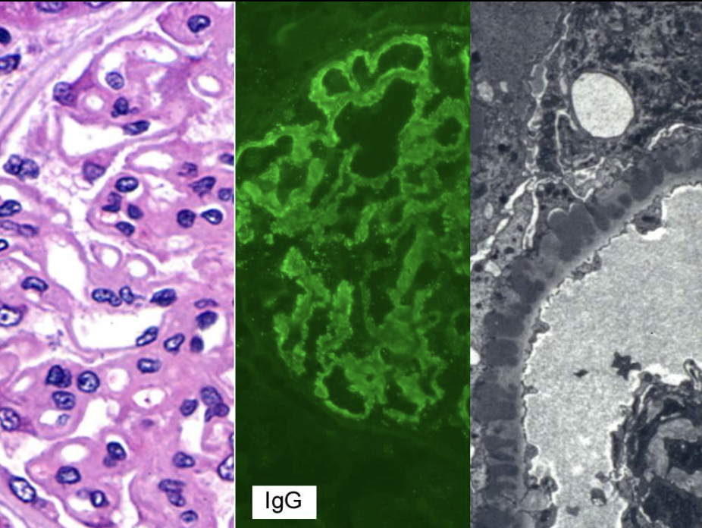
   * in glomerulus 3 cells are present:
     + Endothelial cells (squished tubes)
       - Restrict filtration of cells and macromolecules through fenestrae– Make inflammatory mediators in response to injury
     + Mesangial cells (eosinophilic)
       - Regulate vascular tone
       - Make mesangial matrix
       - Response to injury as effector cells
     + Podocytes (“dusty nuclei” outside capilary)
       - Maintain impermeability to protein filtration (**p**odocytes **p**revent **p**roteinuria)
   * 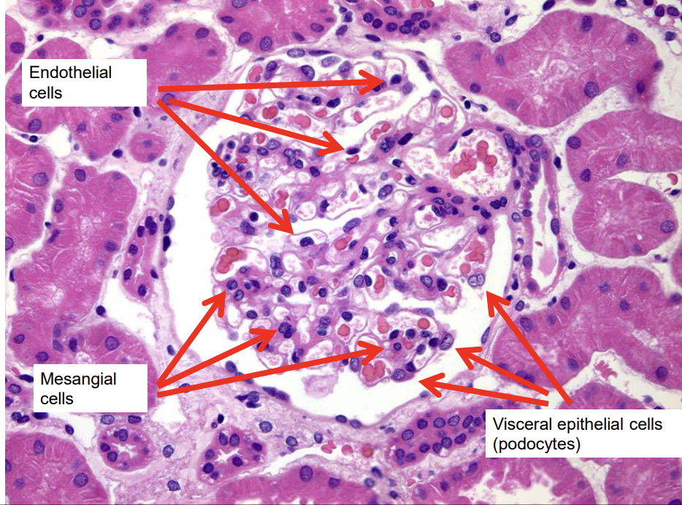
7. **Understand the pathophysiology and clinical presentation of patients with nephrotic syndrome.** 
   * **nephrotic syndrome:** ordered defect in glomerular filtration barrier - “podocyte injury”
   * clinical triad -
     + proteinuria “foamy urine”
     + hypoalbuminemia
     + periorbital and lower extremity edema
     + bonus points: hyperlipidemia, lipiduria (pathognomonic), hypercoagulable state
   * podocytes are fused in nephrotic syndrome, but not in the whole kidney, some areas of fusion and some of wide open GBMs, so their GFR can be normal
   * 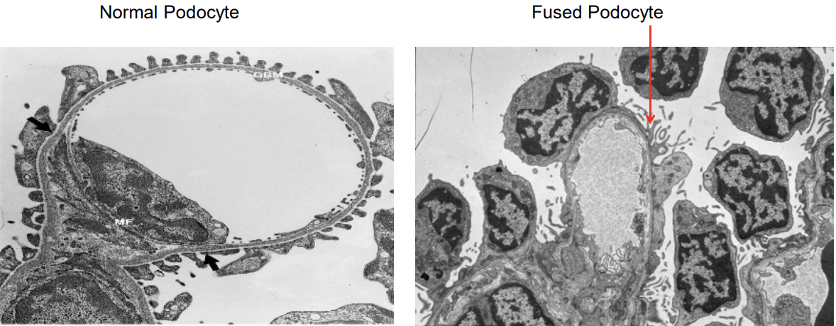
   * Edema in nephrotic syndrome
     + could be due to “underfill” - low oncotic pressure - water moves from plasma to interstitial (however this theory is not validated)
     + could be due to “overfill” - sodium retention keeps water in the body
   * Hyperlipidemia can be seen seen in nephrotic syndrome (Poorly understood but clinically relevant)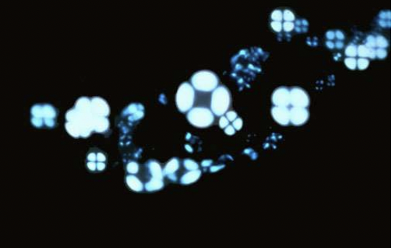
     + Hypercholesterolemia
       - Decreased oncotic pressure stimulates hepatic lipoprotein synthesis
     + Hypertriglyceridemia
       - Impaired metabolism
     + lipiduria (lipids are birefringent) - pathognomonic
       - “maltese cross” under polarized light
   * Hypercoagulable state - due to loss of more anticoagulation proteins than procoagulation proteins
     + loss of antithrombin III, Protein C & S, increased platelet activation, hyperfibrinogenemia
8. **Formulate a differential diagnosis of a patient with glomerular disease.** 
   * 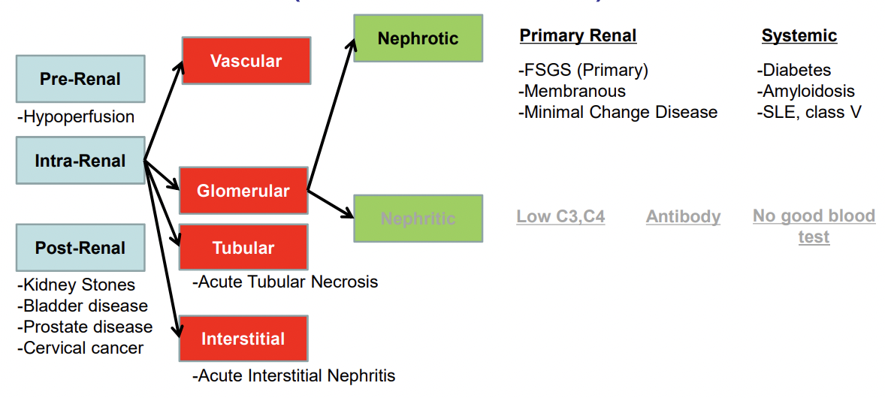
   * Can be primary (due to renal disease) or systemic
9. **Describe the basic anatomy of the kidney and the basic immune mechanisms of glomerular injury.** 
   * see below
10. **Describe the various morphologic abnormalities that occur in the glomerulus.** 
    * see below
11. **Describe the nephrotic syndrome.** 
    * Most common cause of nephrotic syndrome in adults is **FSGS**
    * APOL1 risk alleles are more common in african americans
    * Most common cause of nephrotic syndrome in children is **minimal change disease**
    * most common cause of end stage renal disease is **Diabetic Nephropathy**
12. **Describe the light, electron microscopic, and immunofluorescence features of minimal change disease, focal segmental glomerulosclerosis, membranous glomerulopathy, diabetes, and amyloidosis.** 
    * **Primary Focal segmental glomerulosclerosis (FSGS)**
      + partial scarring of glomeruli - only acts on kidneys, no other clinical impacts
      + only some glomeruli are effected and it is segmental, there will be normal parts of each glomeruli
        - *other processes can scar the whole glomeruli “global glomerulosclerosis”
      + 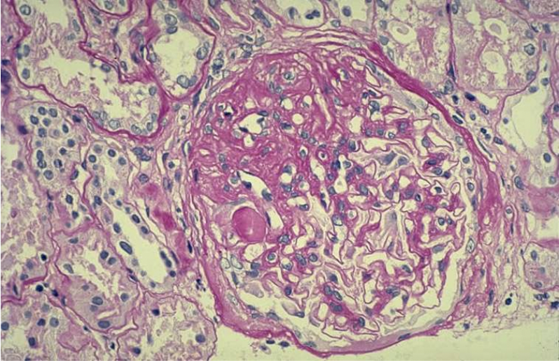PAS 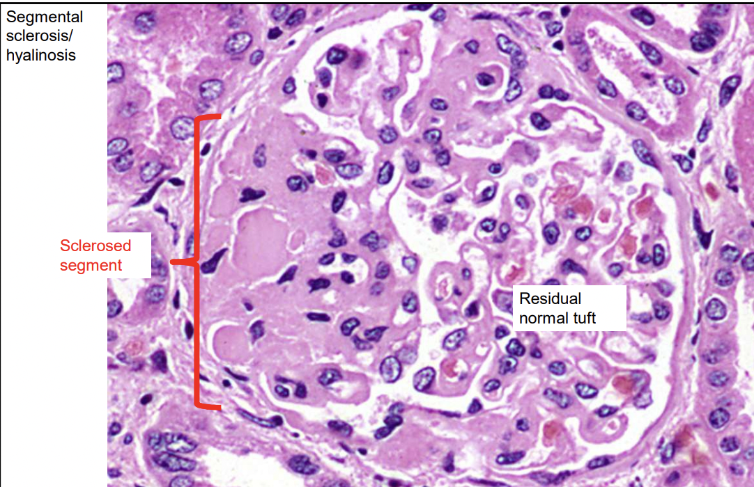H&E
      + Cause: idiopathic(primary), familial causes, infection (HIV, COVID), drugs (heroin, interferons)
    * **Secondary FSGS is not a nephrotic syndrome**
      + is from hydronephrosis, obesity (hyperfiltration)
    * **Membranous Nephropathy**
      + autoimmune destruction of podocyte, effacement of podocyte from GBM, deposits in subepithelial region
      + more common in age >60, men
      + **Cause**: primary (idiopathic), secondary (solid tumors - paraneoplastic process, lupus, etc)
      + histology - attack on the podocyte at the PLA2R protein
        - 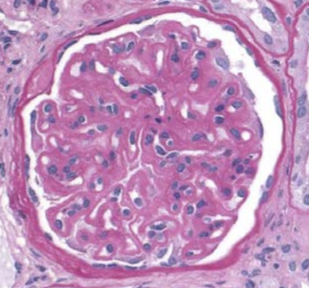PAS - diffuse thickening of capillary loops
        - 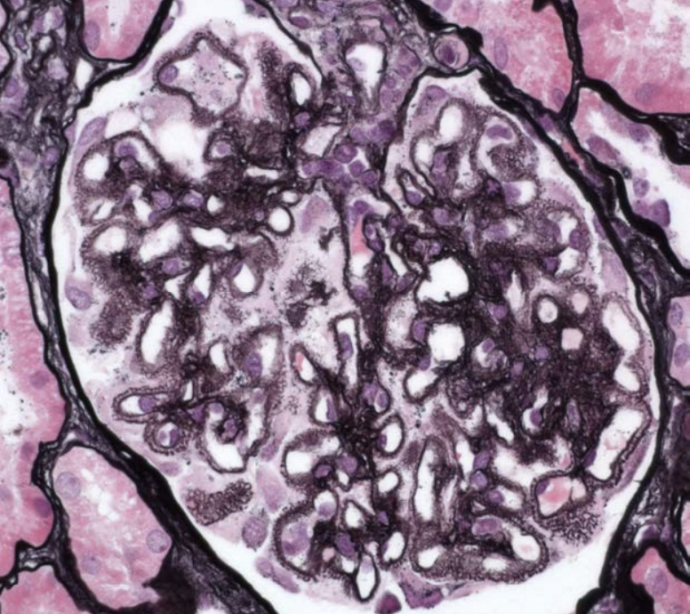silver stain - subepithelial deposits with intervening spikes, GBM remodeling into little protrusions
        - 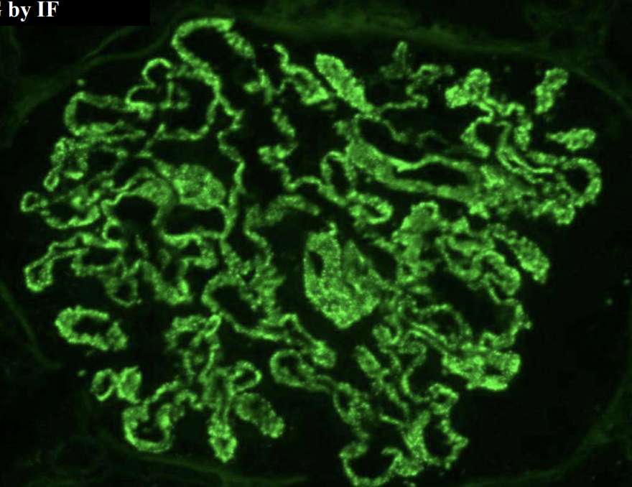 IF - *granular* IgG staining - autoantibodies to podocytes
    * **Minimal change disease**
      + most common cause of nephrotic syndrome in kids
      + primary (idiopathic), secondary (NSAID use, liquid malignancies)
      + looks normal on light microscopy, IF, but you can see podocyte defacement on SEM
    * **Diabetic Nephropathy**
      + increased GBM matrix (glycosylation)
      + increased mesangial matrix
      + early diabetic nephropathy
        - 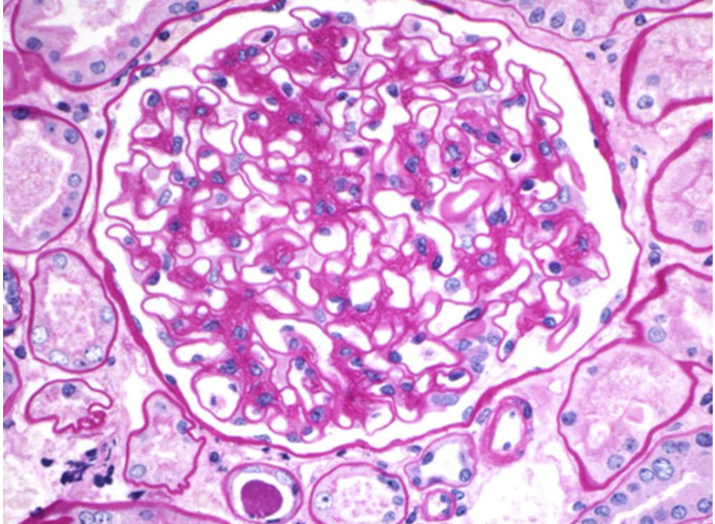PAS 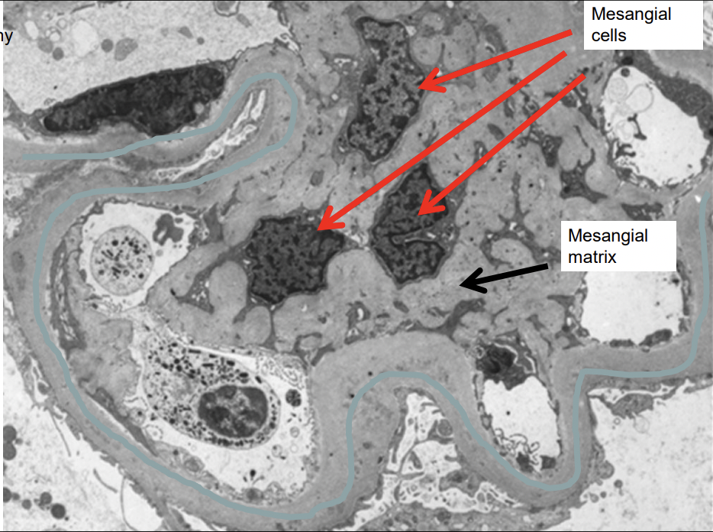SEM GBM is thick
      + Advanced diabetic nephropathy - lowered GFR -
        - “Diffuse nodular mesangial sclerosis” Kimmelstiel wilson nodules 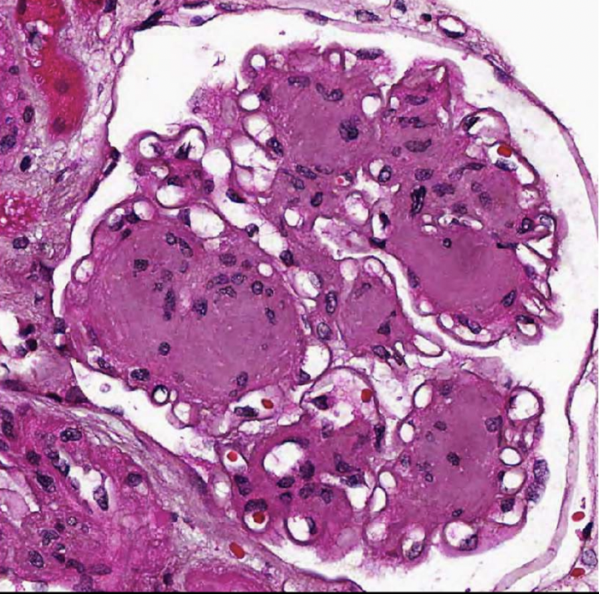
        - pretty much pathognomonic
    * **Amyloidosis**
      + in older pts
      + variety of amyloid disorders - from amyloidosis, or secondary to chronic inflammation (rheumatoid arthritis)
      + amorphous amyloid deposits
        - 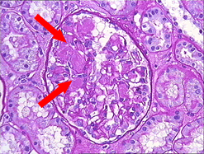
    * **Lupus (SLE)**
      + “full house” IF staining of IgG, IgA, etc
      + 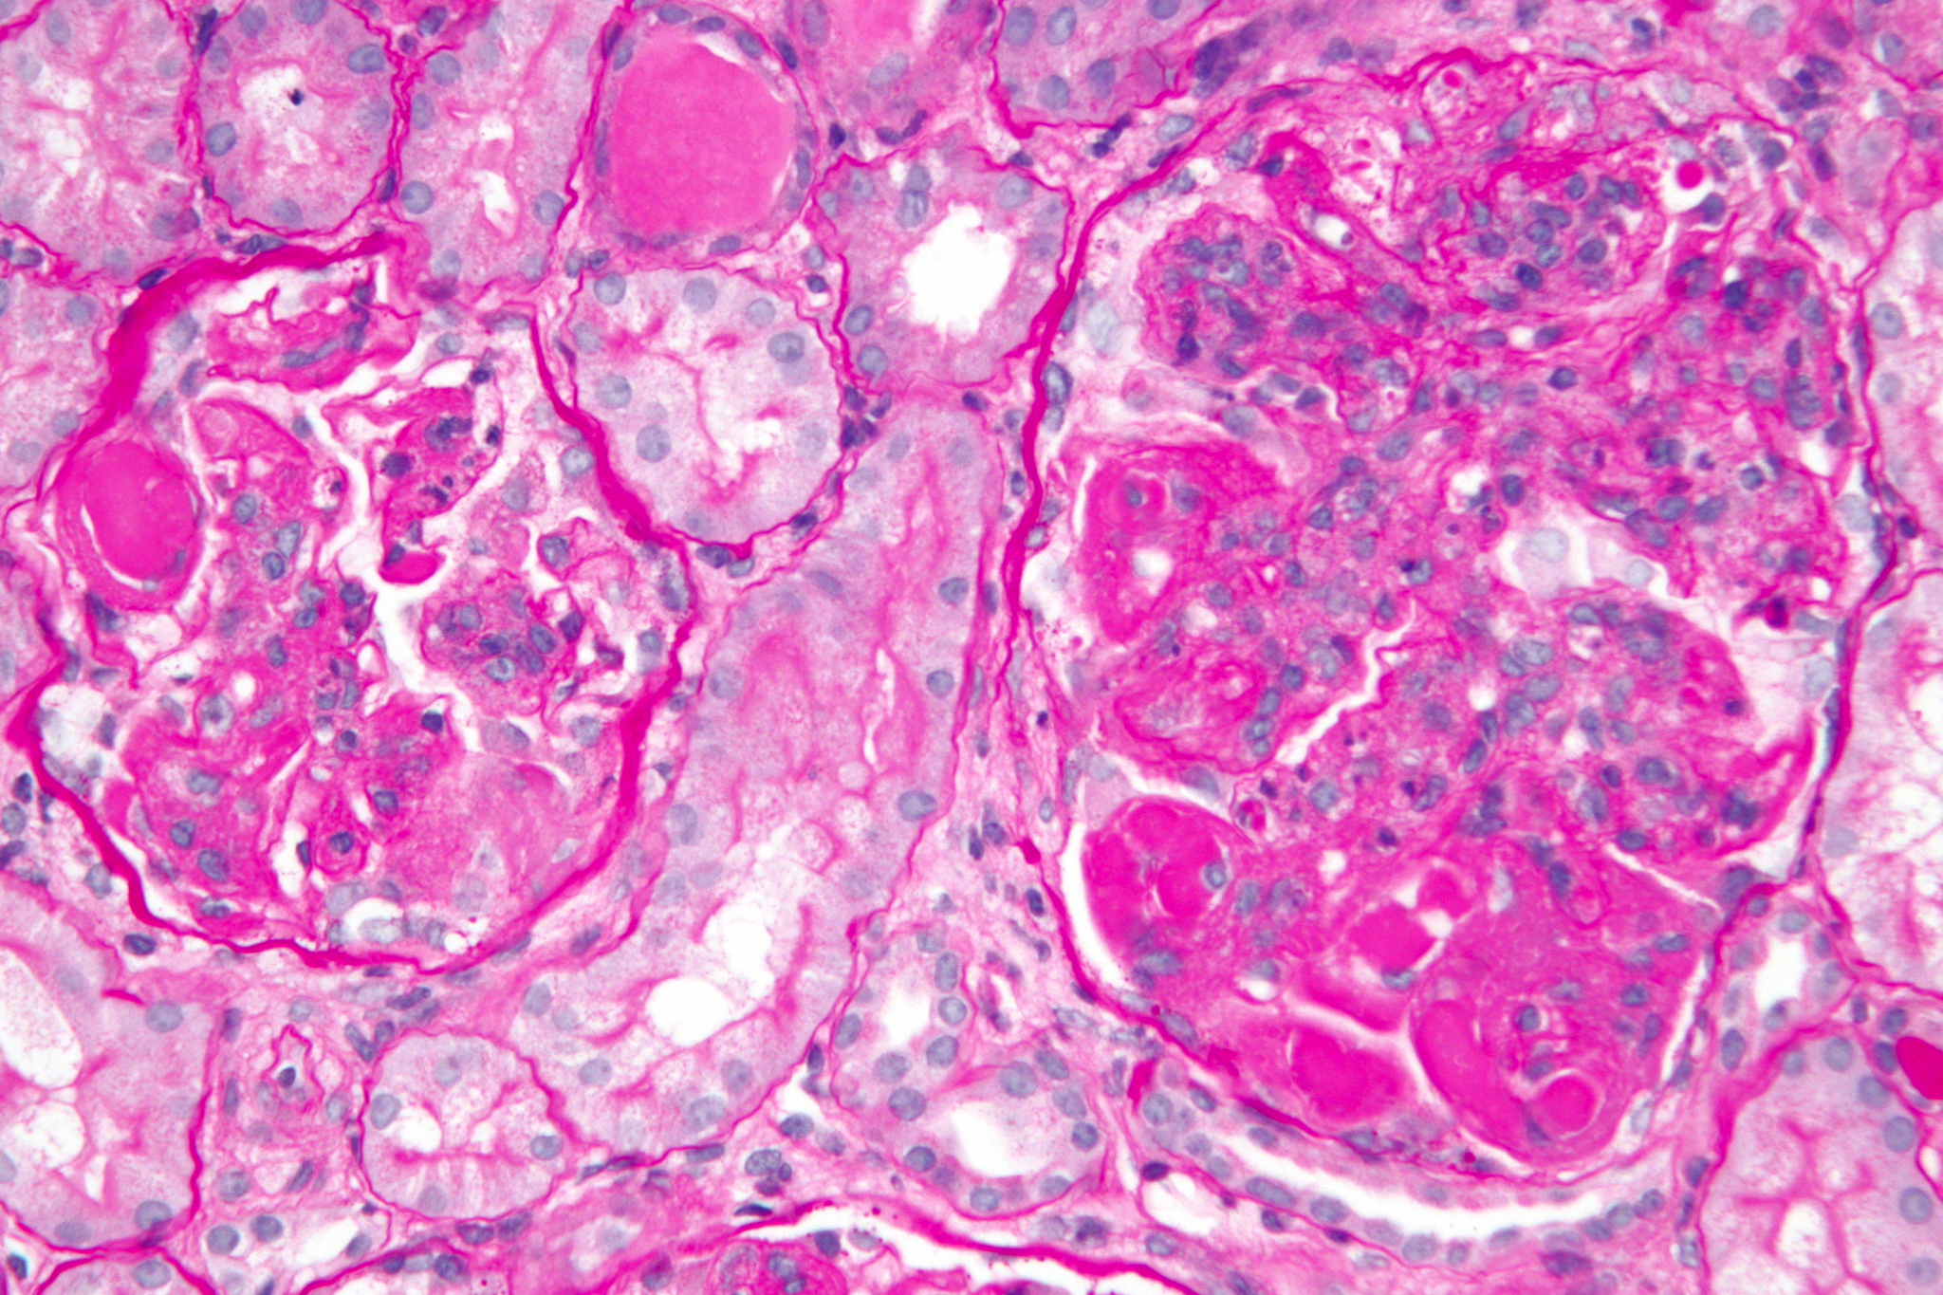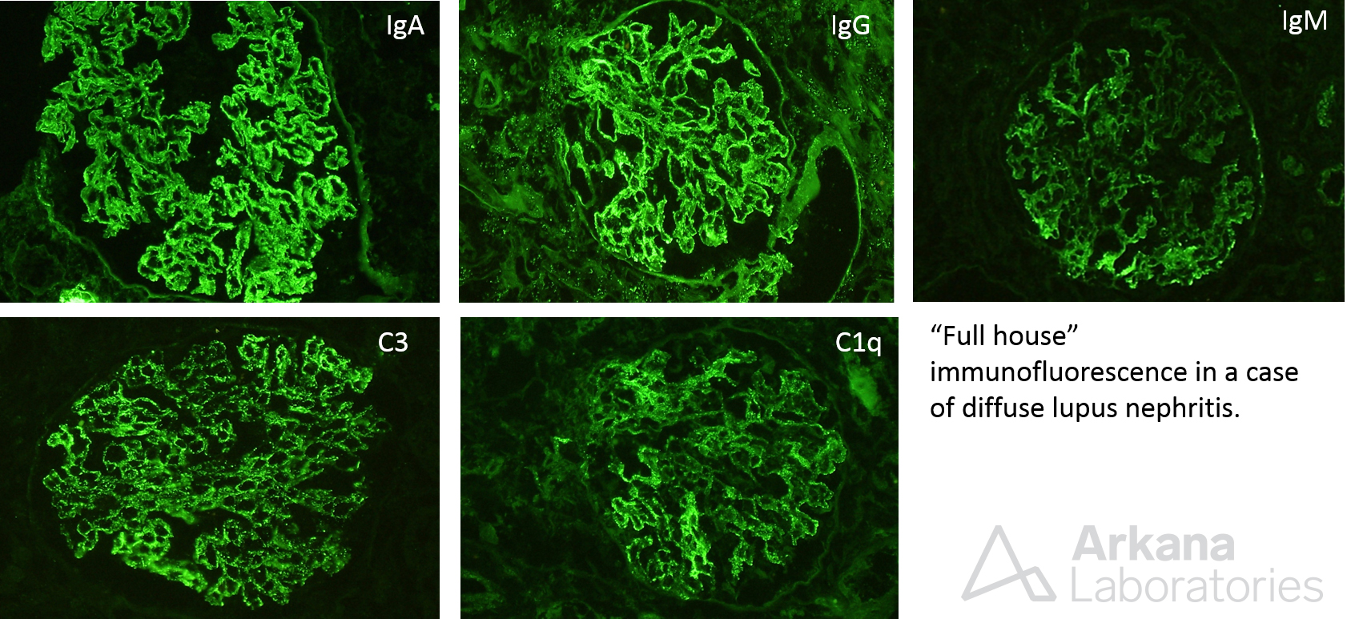
13. **Relate the morphologic features to clinical and laboratory findings.** 
    * Kidney biopsy is required for nephrotic syndromes because they diseases are described by glomeruli structure